**Power BI**

**Ability to understand key features of Power BI and creating a report**

Software to install:

Microsoft Power BI, <https://powerbi.microsoft.com/en-us/downloads/>

The Above link Directs you to this page

Step 1: Click on Advanced Download Options

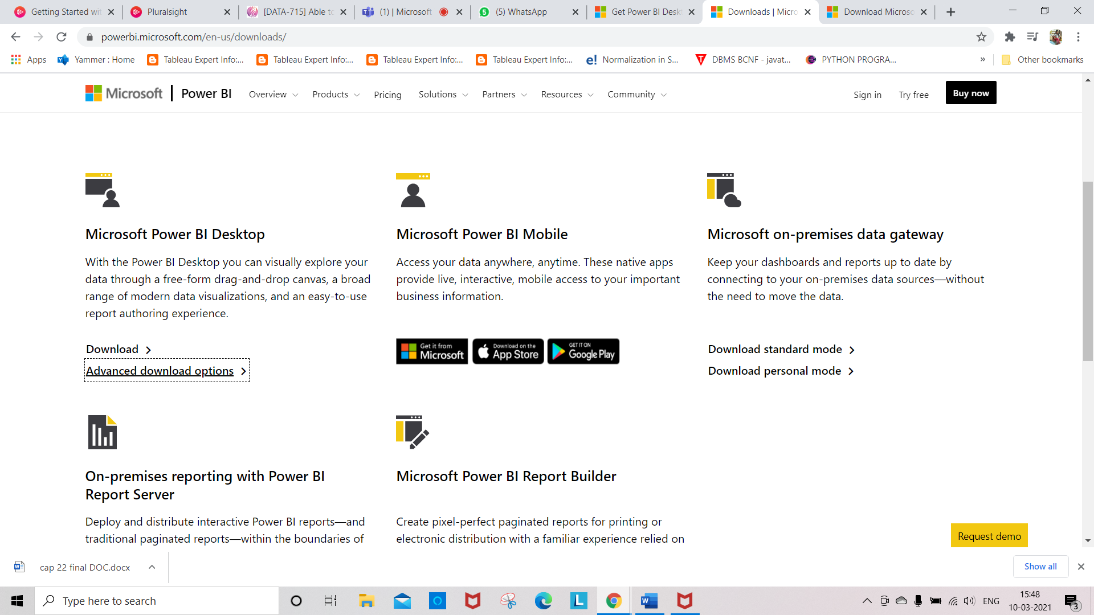

Step 2: We can select a language in which we want to install Power BI and following details are available for download.

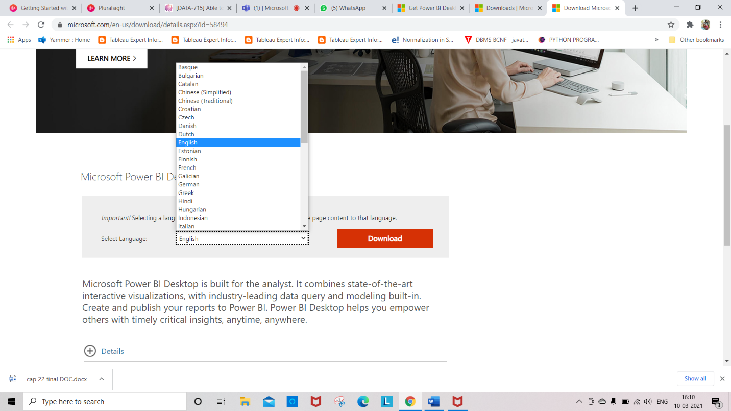

Step 3: To download the Power BI Desktop executable from the Download Center, select **Download** from the [Download Center page](https://www.microsoft.com/download/details.aspx?id=58494). Then, specify a 32-bit or 64-bit installation file to download

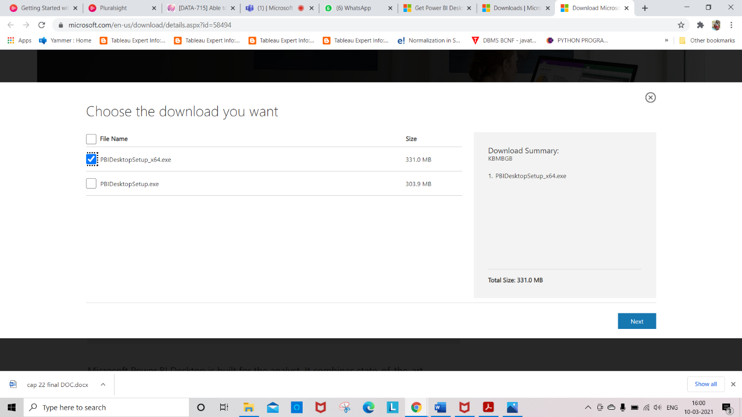

Step 4: After Downloading PowerBI file, Double click on the PBIDesktopSetup_x64 file from the Downloads

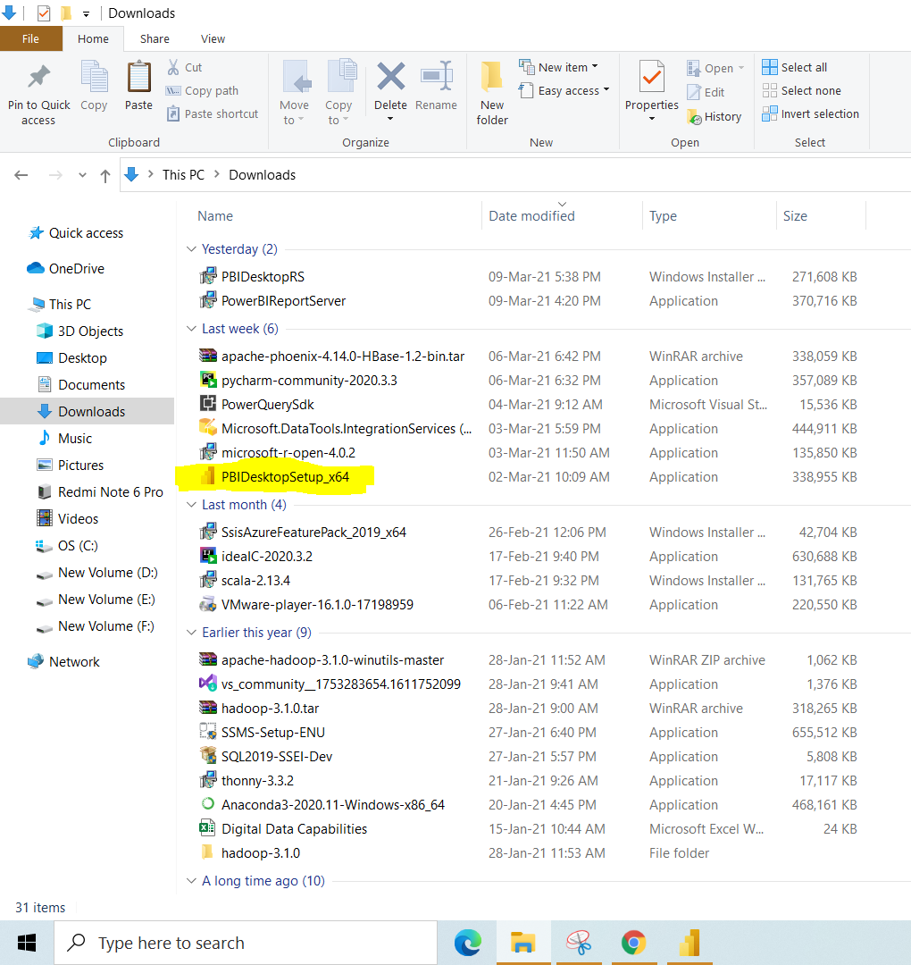

Step 5: Click on Next until you are asked to install

Step 6: Click on Install

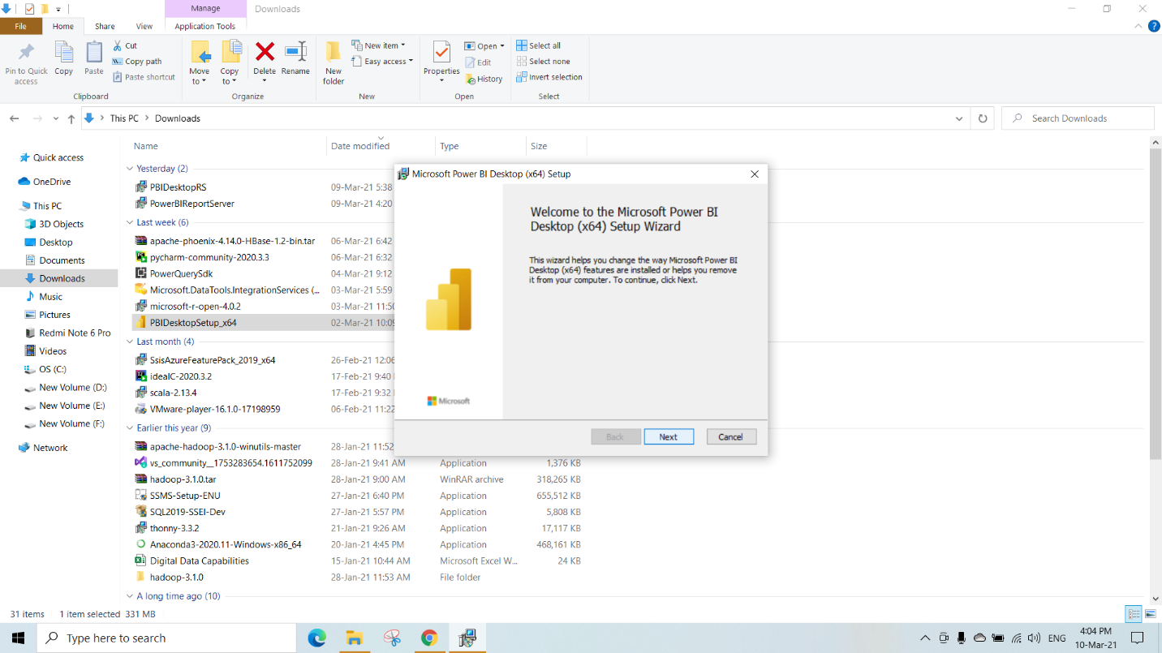

Step 7: After you launch the installation package, Power BI Desktop installs as an application and runs on your desktop.

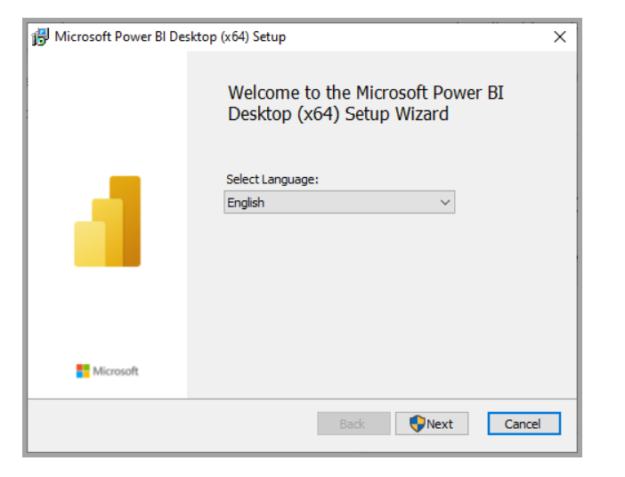

Step 8: Accept the license agreement and follow the instructions given to finish the installations.

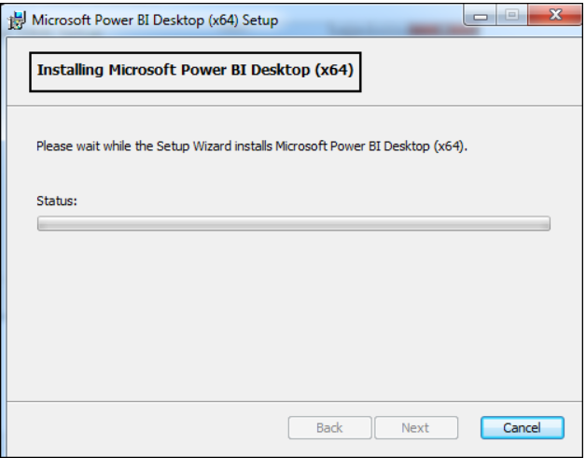

Step 9: After Completing the Installations

Click on Finish

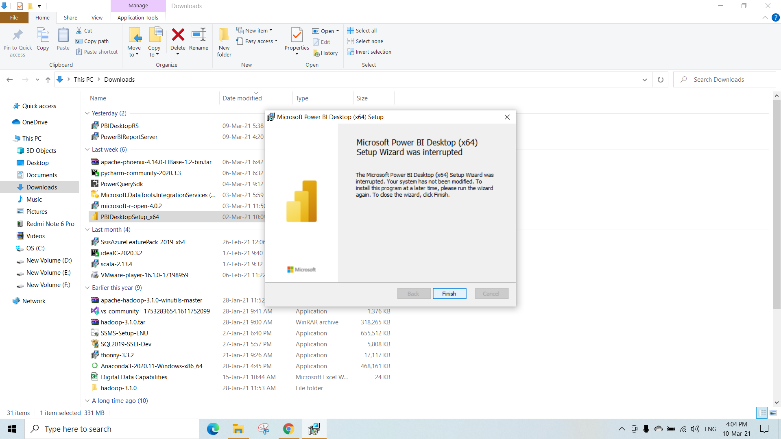

When Power BI is installed, it launches a welcome screen. This screen is used to launch different options related to get data, enrich the existing data models and to create reports as well as publish and share reports.

**POWER BI**

Power BI provides cloud-based BI (business intelligence) services, known as "Power BI Services", along with a desktop based interface, called "Power BI Desktop". It offers data warehouse capabilities including data preparation, data discovery and interactive dashboards.

Key components of the Power BI ecosystem comprises:

1. Power BI Desktop

The Windows-desktop-based application for PCs and desktops, primarily for designing and publishing reports to the Service.

1. Power BI Service

The SaaS-based (software as a service) online service. This was formerly known as Power BI for Office 365, now referred to as PowerBI.com, or simply Power BI.

**KO1: Able to Prepare Data for Power BI**

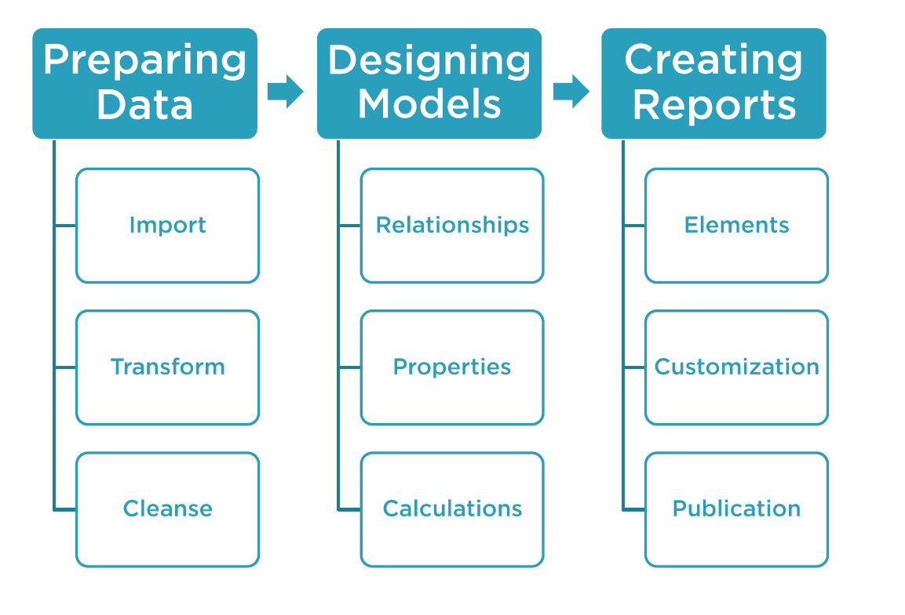

IMPORTING DATA

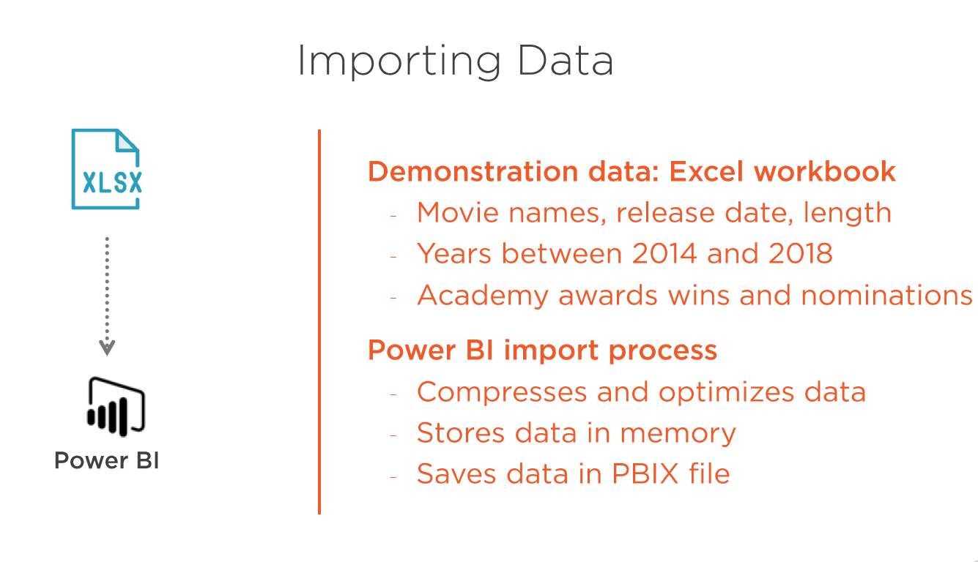

This is how Power BI looks when we open the Power BI Desktop Application

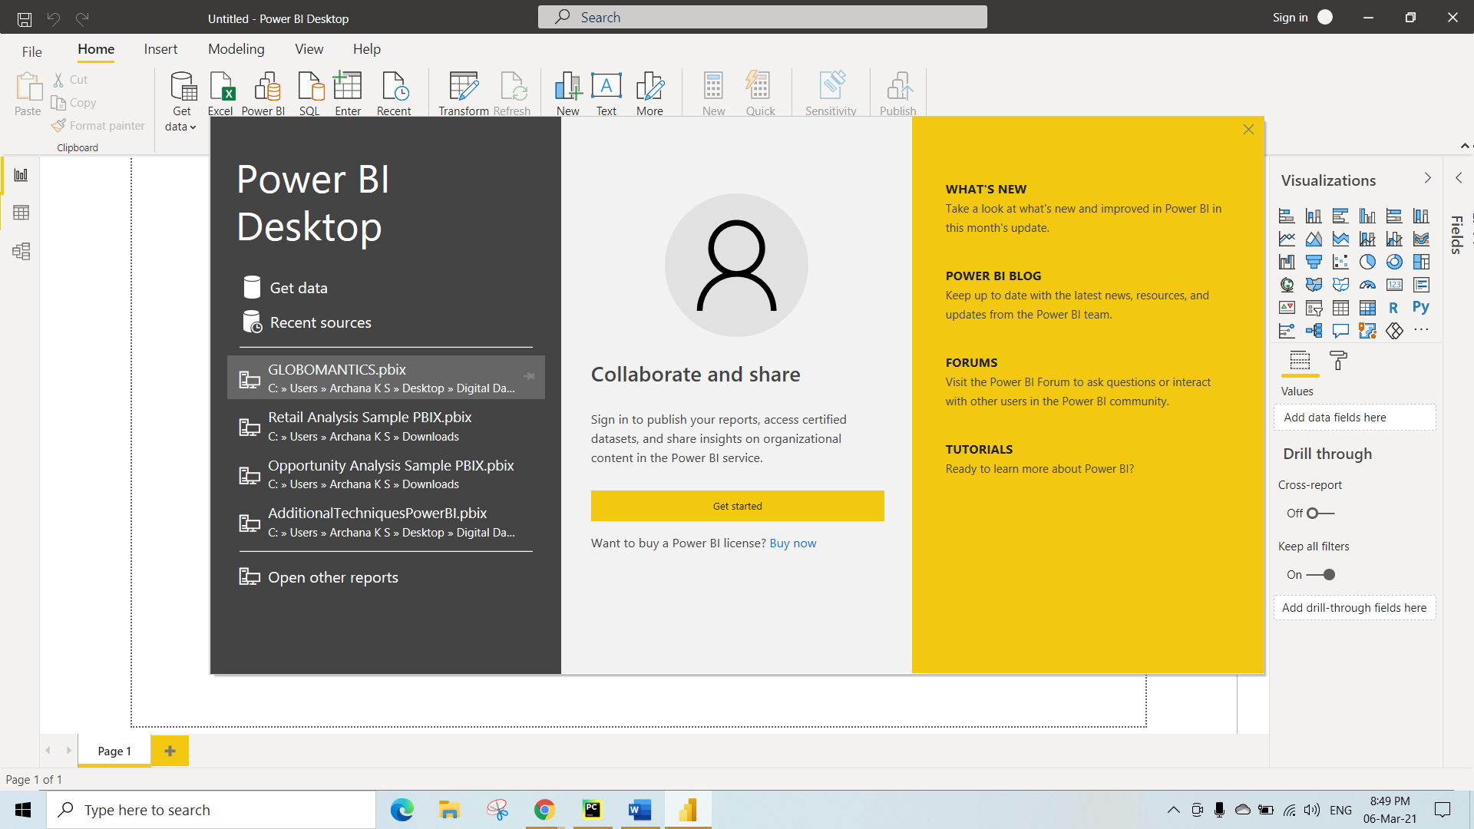

Close this above Pop-Up

We can Load different types of files in PowerBI

Here, We are Loading Excel file ,

Step 1: Click on **GetData**

Step 2: Select Excel and Click on **Connect**

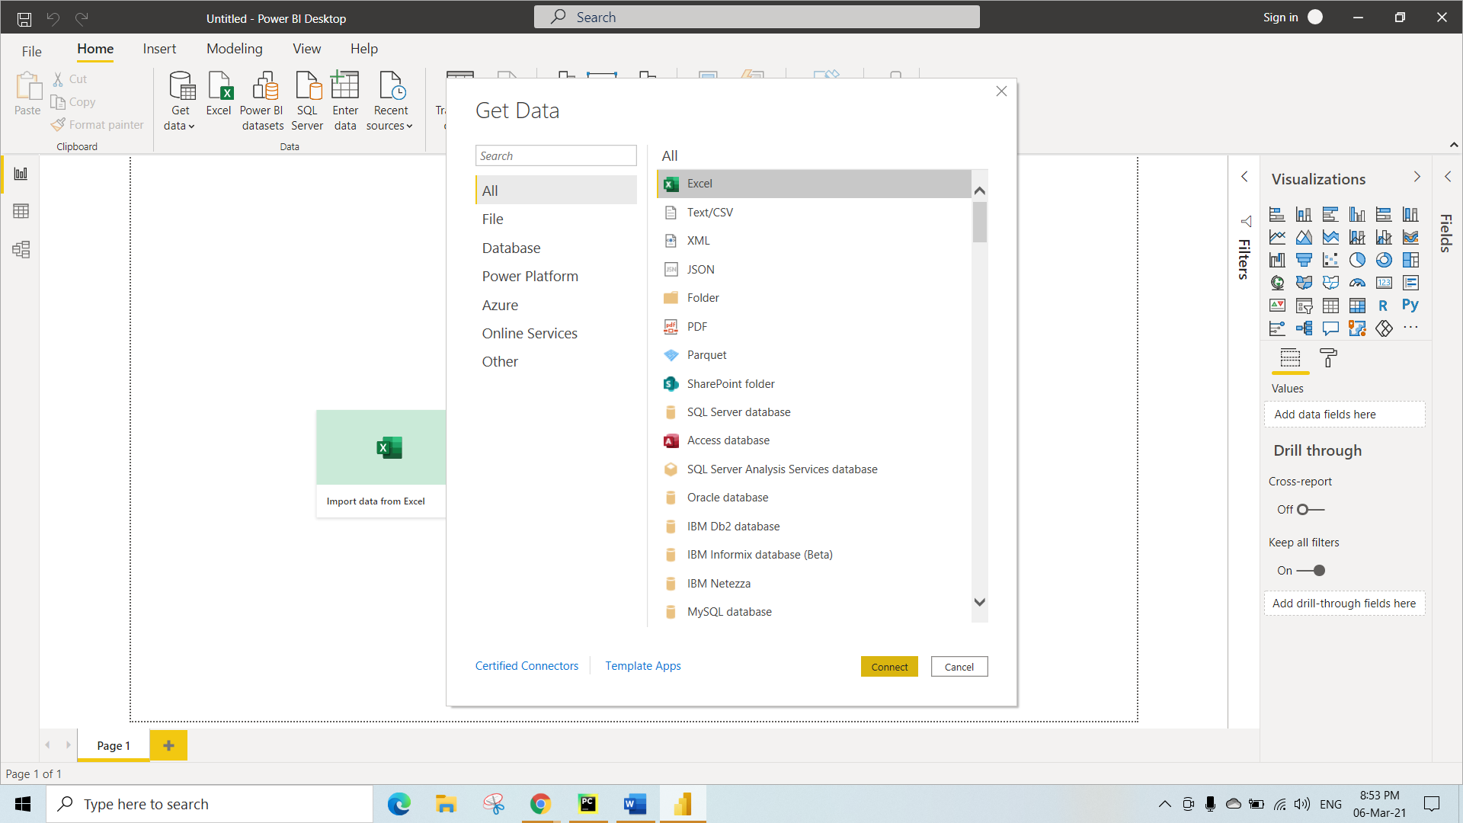

Here we are loading Titles.csv File and Click on Open

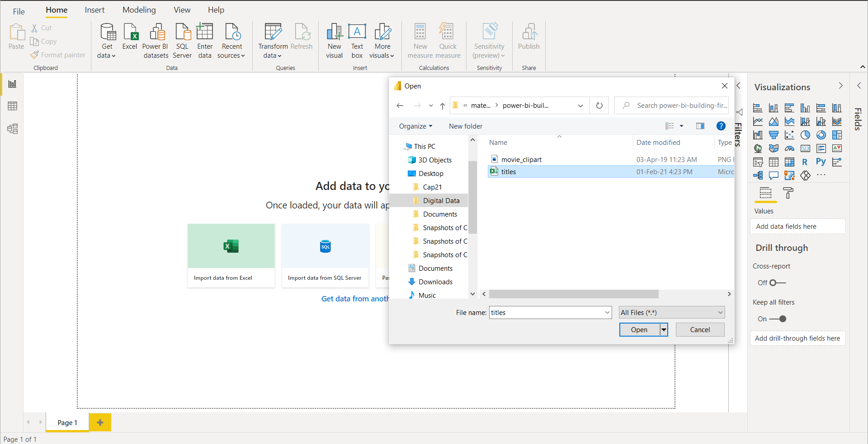

Here we have to select table3 under Navigator Bar

If you want to make any changes in the content of the table then Click on Transform Data or Else Click on Load to load the data in the PowerBI

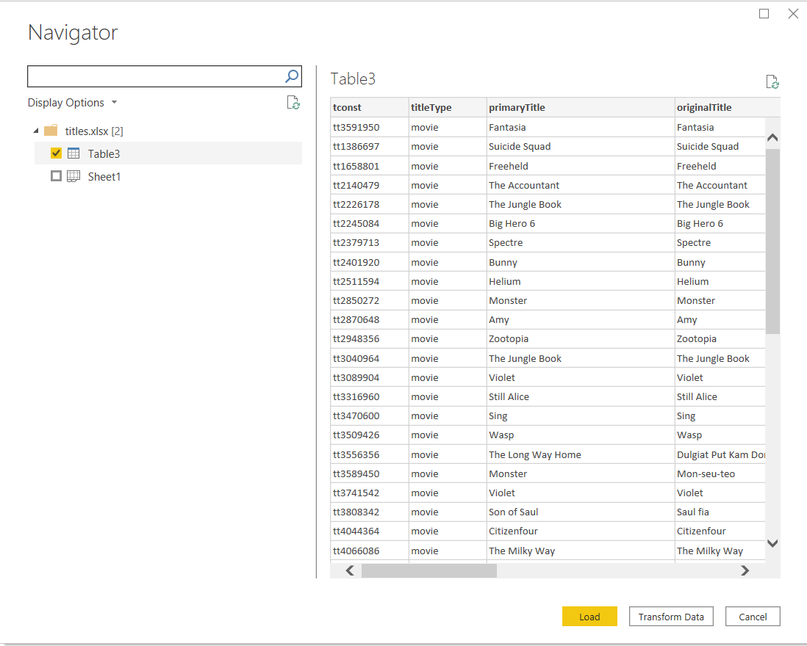

After Loading the Excelfile This is how it looks as shown below

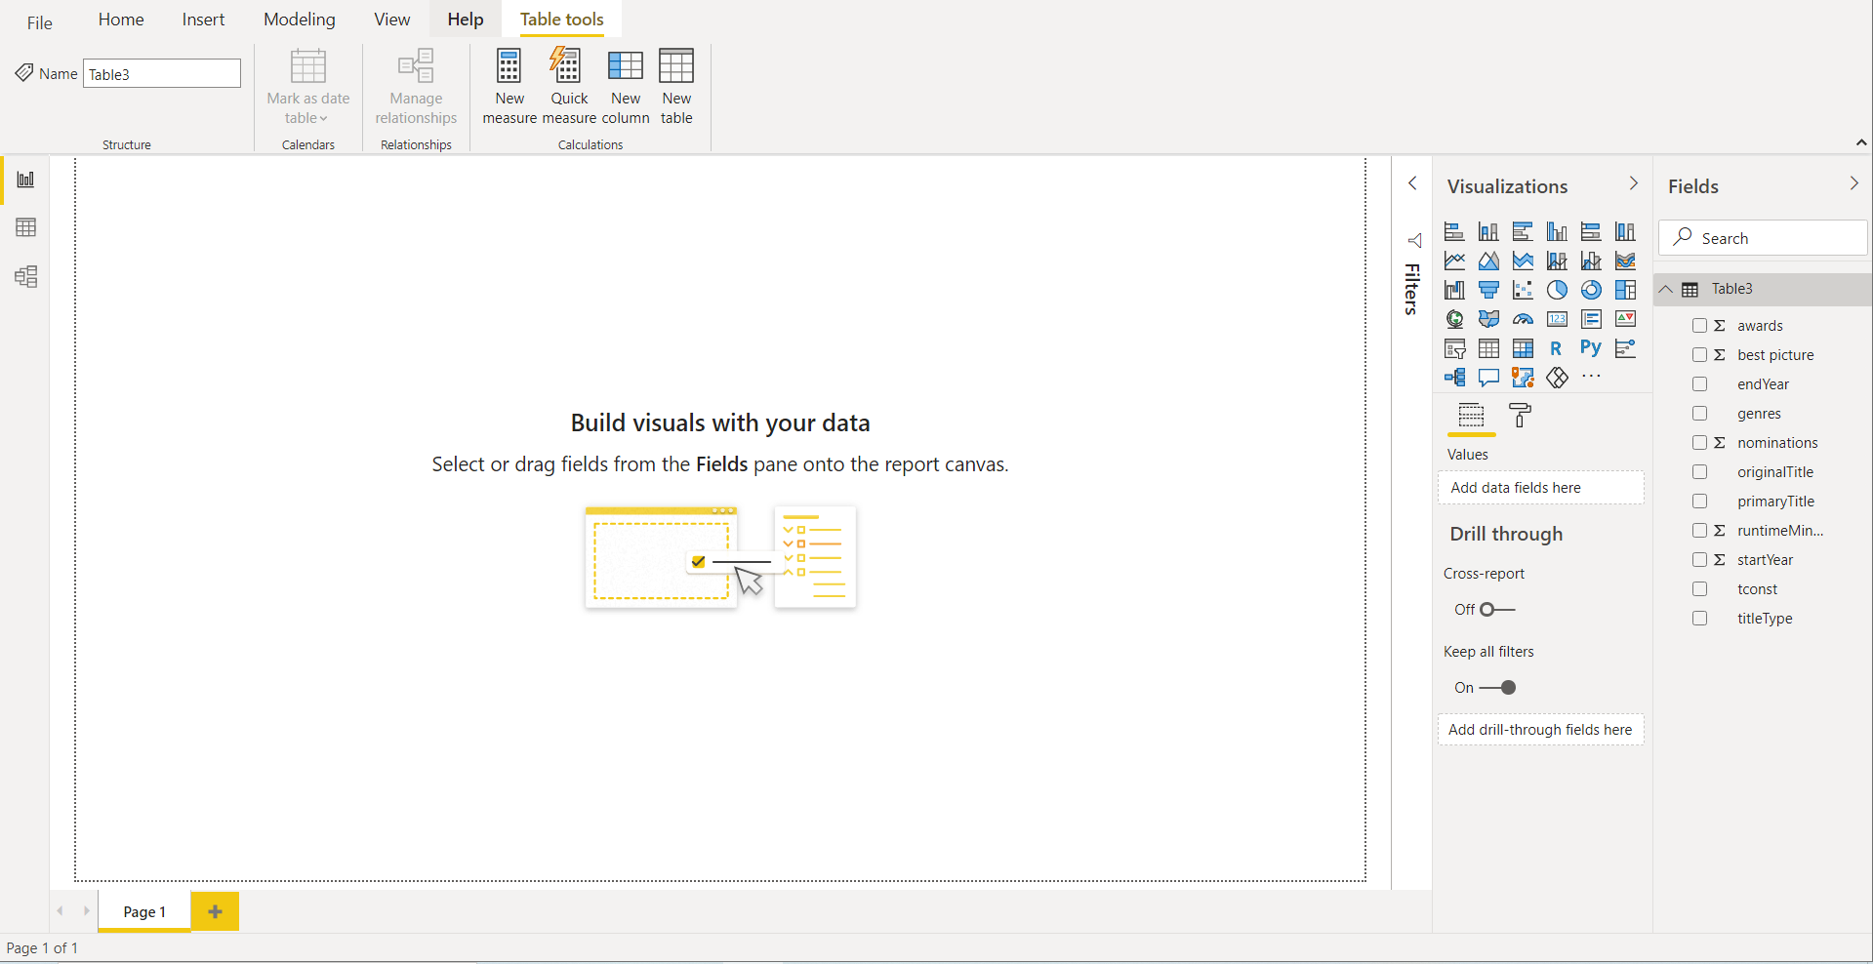

Once after loading the csv File , To make any Transformations

Step 1: Go to **Home**

Step 2: Click on **transform Data**

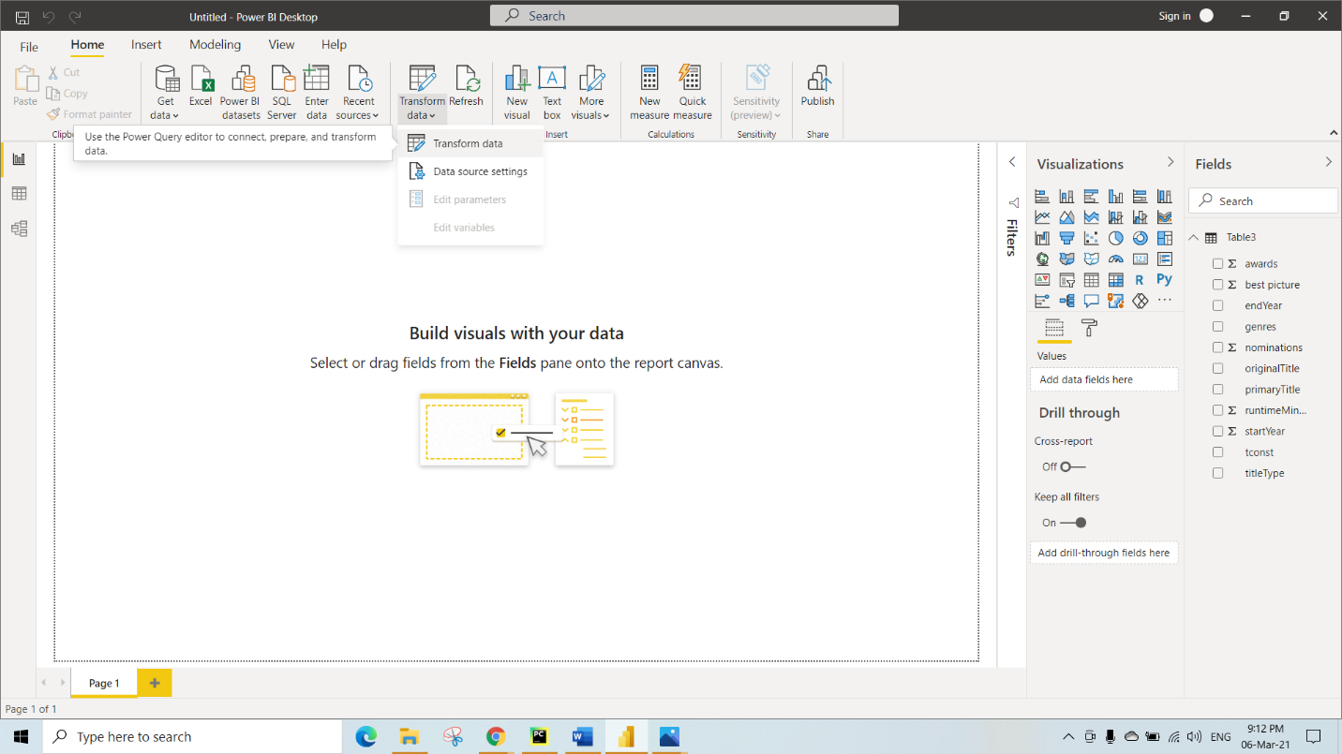

After Clicking on Transform Data We will get the below Power Query Editor Page

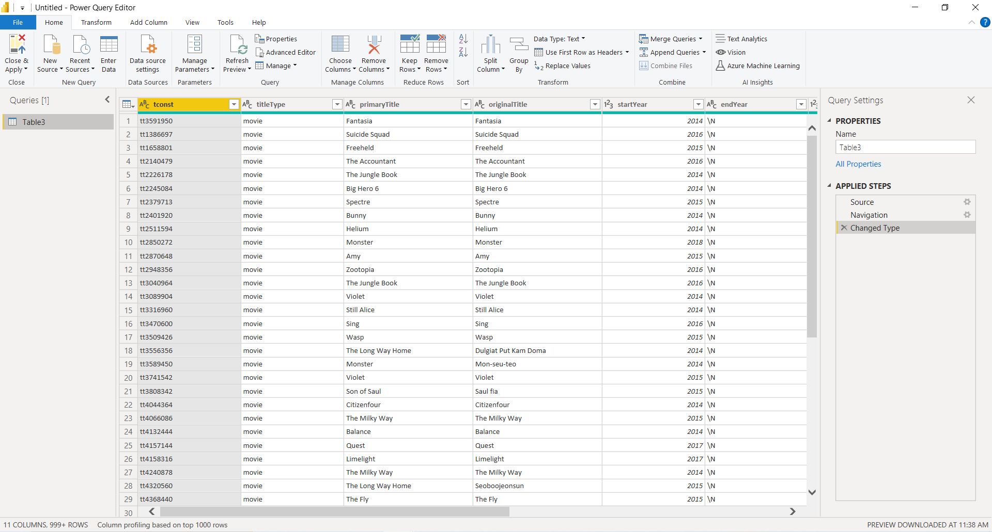

To Remove any Columns in the Table , Right click on the Column and Select Remove .

If you wanted to Remove any other columns apart from the selected columns click on Remove other Columns

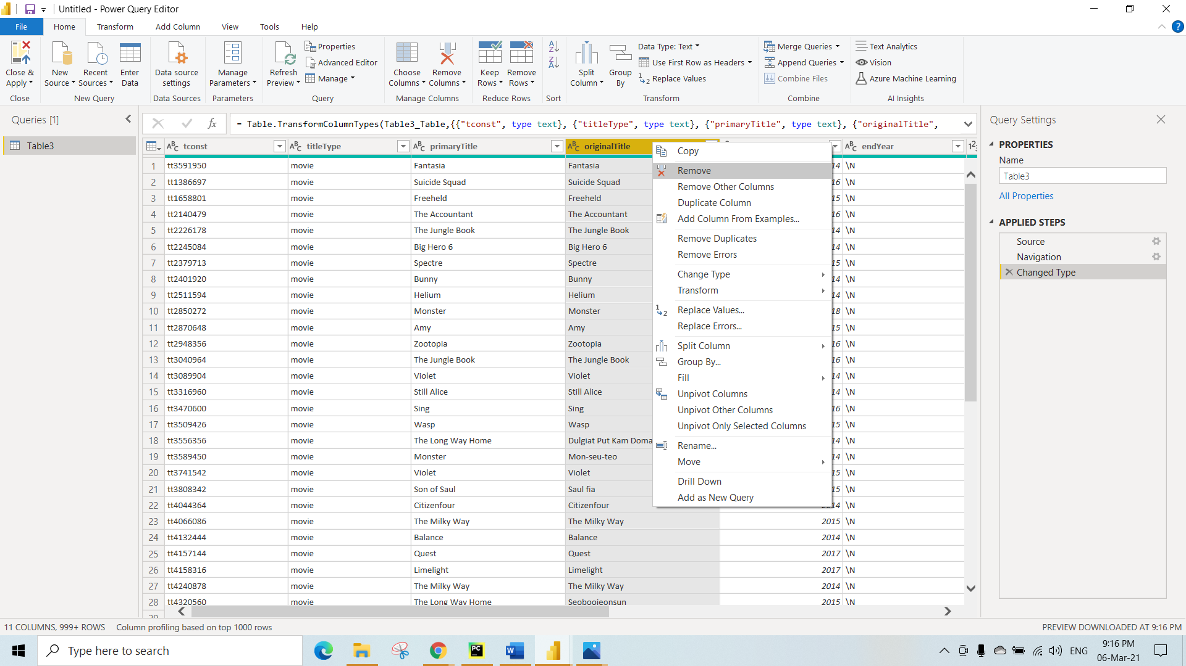

To perform filtering on any columns , click on the drop down of that column and click on Number Filters 🡪 Any Conditions you want to Perform

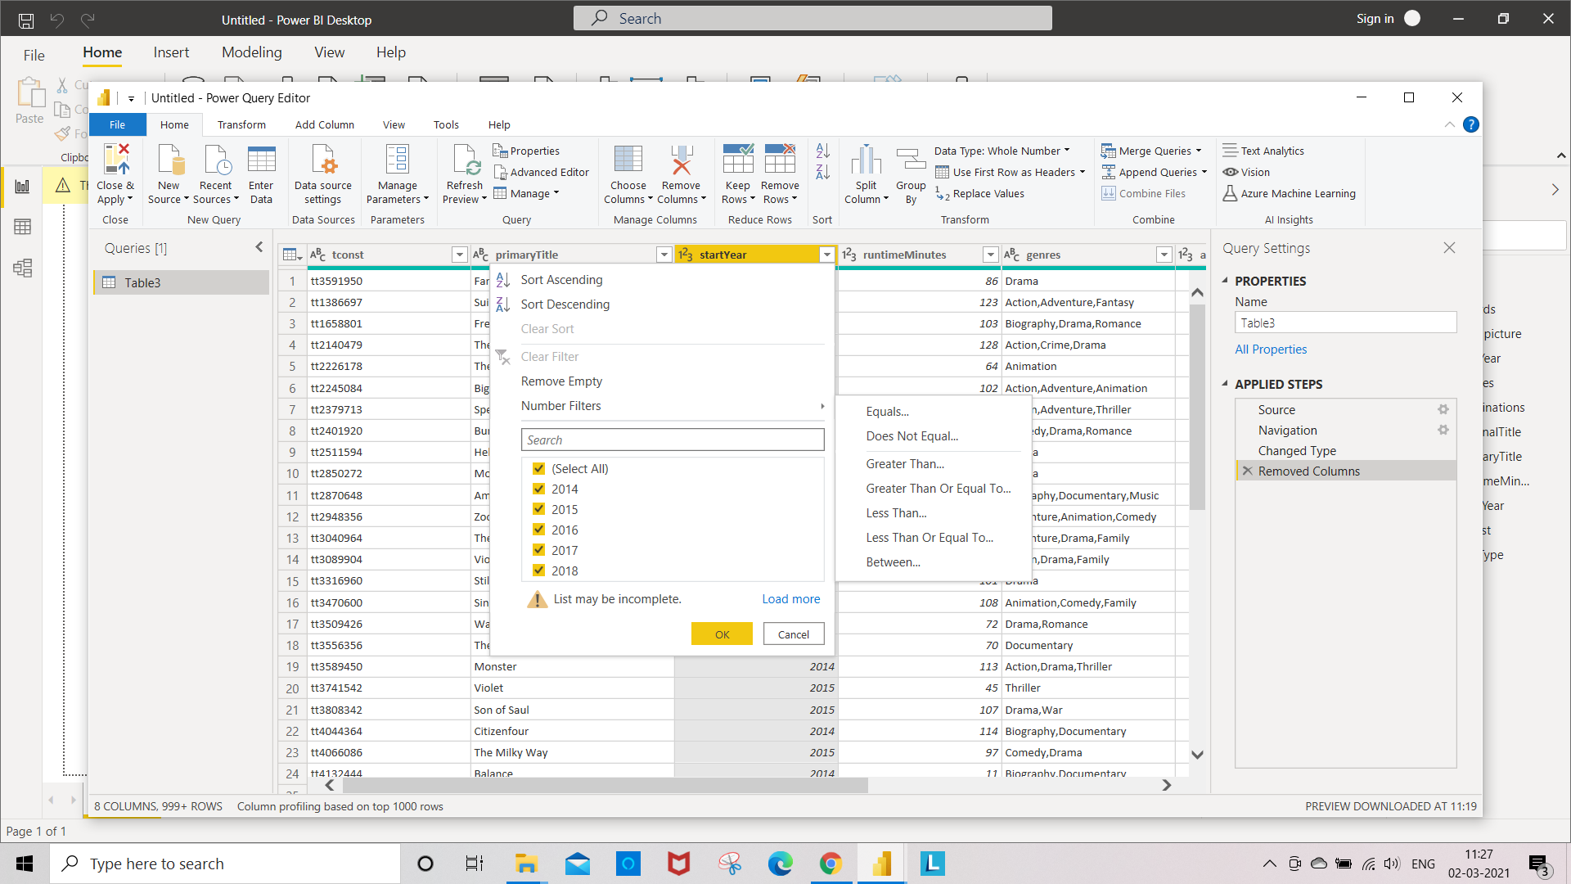

After Selecting , Number Filters 🡪 Greater Than or Equal To

You can apply one or more filter conditions to the rows in the table

We have given Greater Than or Equal To 🡪 2014( We will get all the records from the startYear which is Greater Than or Equal To 2014)

Click on Ok

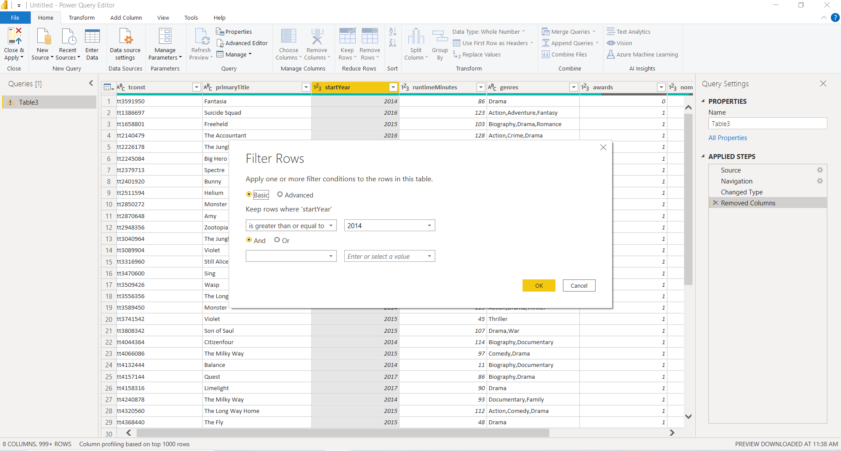

Fixing MetaData

To Rename any Table name, under the Properties You can type the new Table name

To Rename any column , Right click on column and select rename

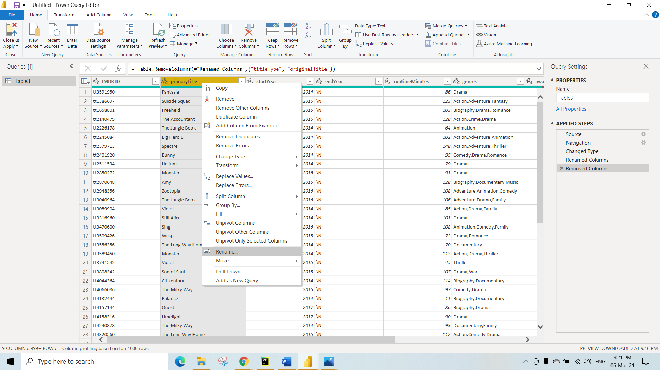

Renamed Table Table3 🡪 Movie

Renamed Column IMDB ID 🡪 Movie ID

primaryTitle 🡪 Title

startYear 🡪 Released Year

runtimeMinutes 🡪 Duration

genres 🡪 Genres

After performing some Transformations you can see each operations whatever you have performed in the Applied Steps

To Sort columns , Right click on the Column and select Sort Ascending or Descending order

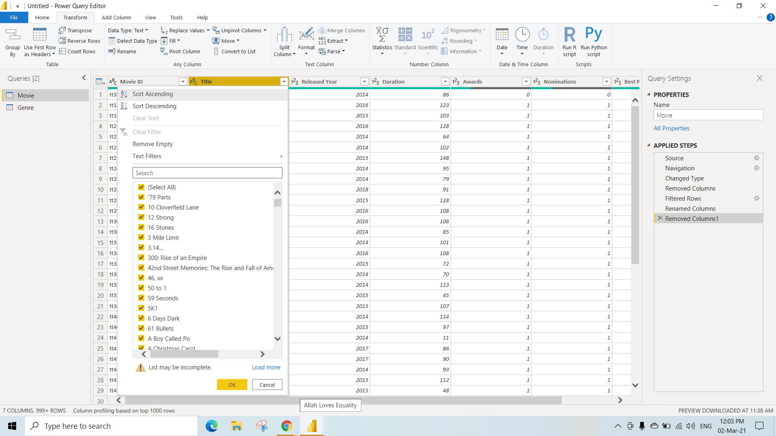

To make another copy of the same table , Right Click on the table and select duplicate

Here we have duplicated Movie table and renamed the duplicated table as Genre

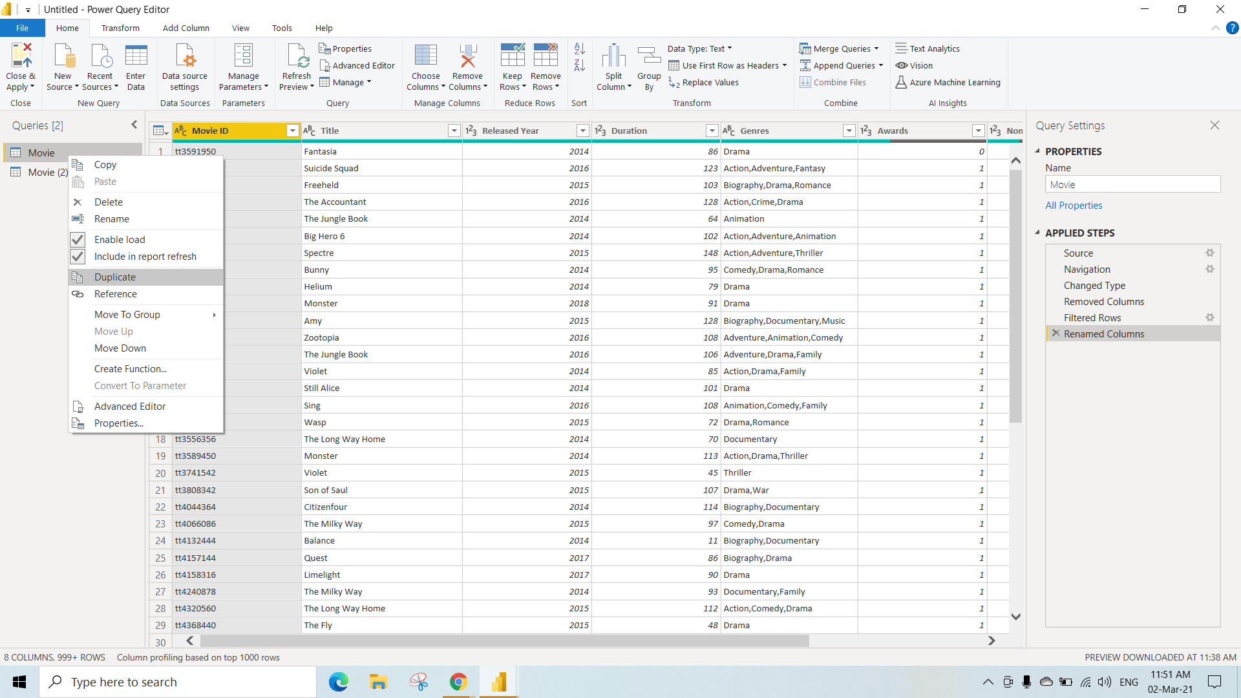

To Split any columns , Right click on the column

Select Split column 🡪 Delimiter(You can select any Options)

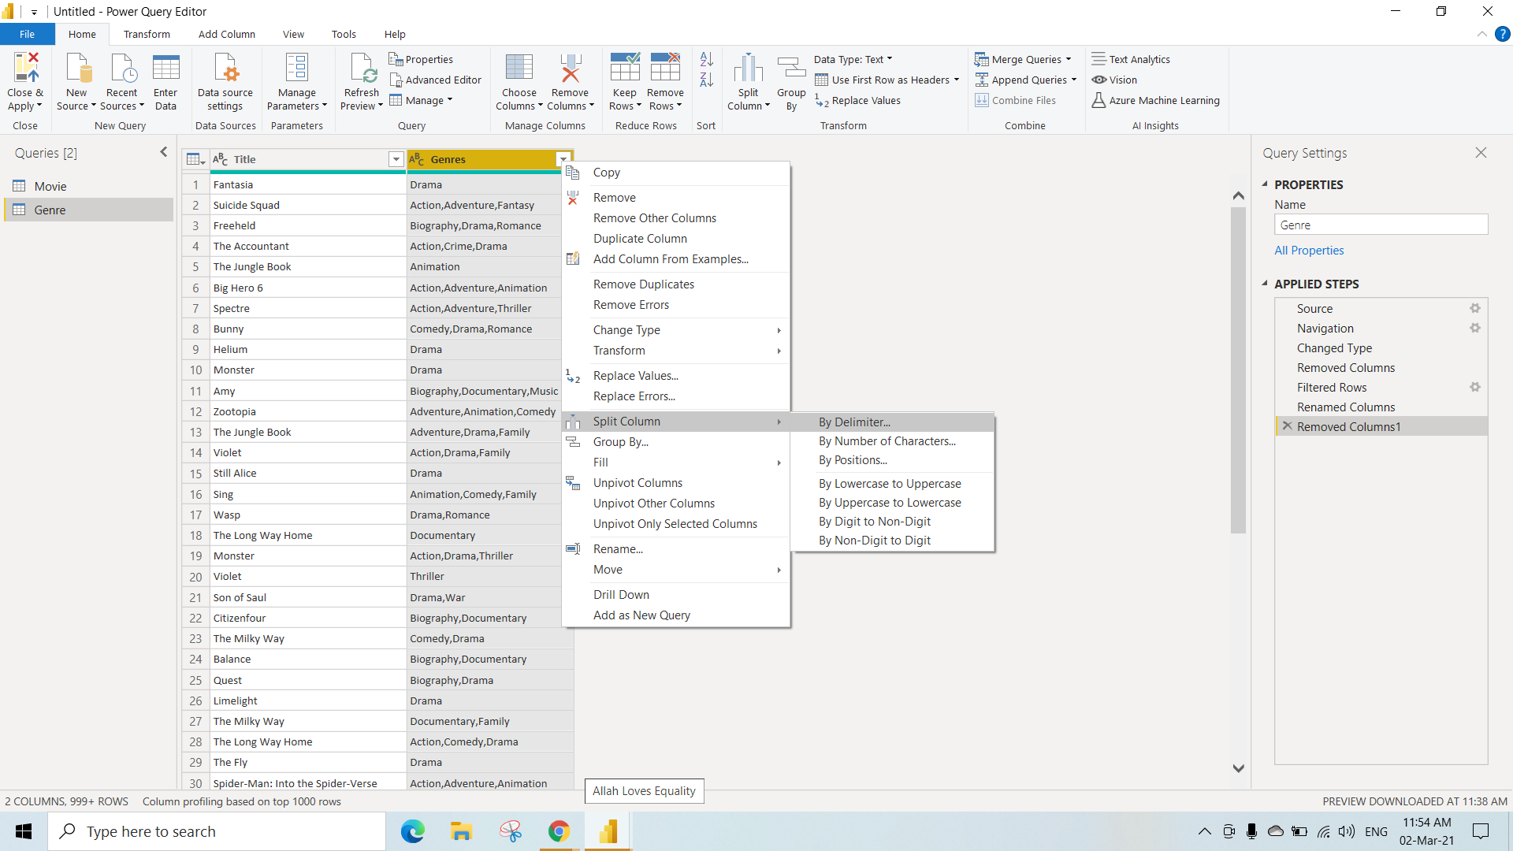

We are Splitting the Genres Column, By each occurances of the delimiter

Click on **Ok**

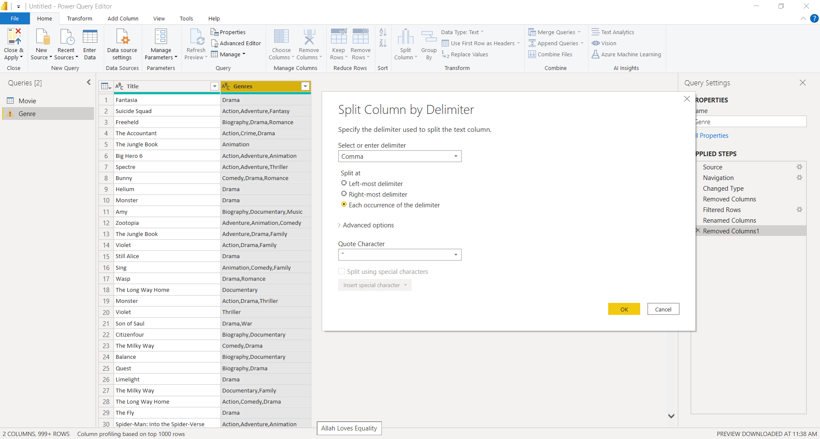

After splitting We get this

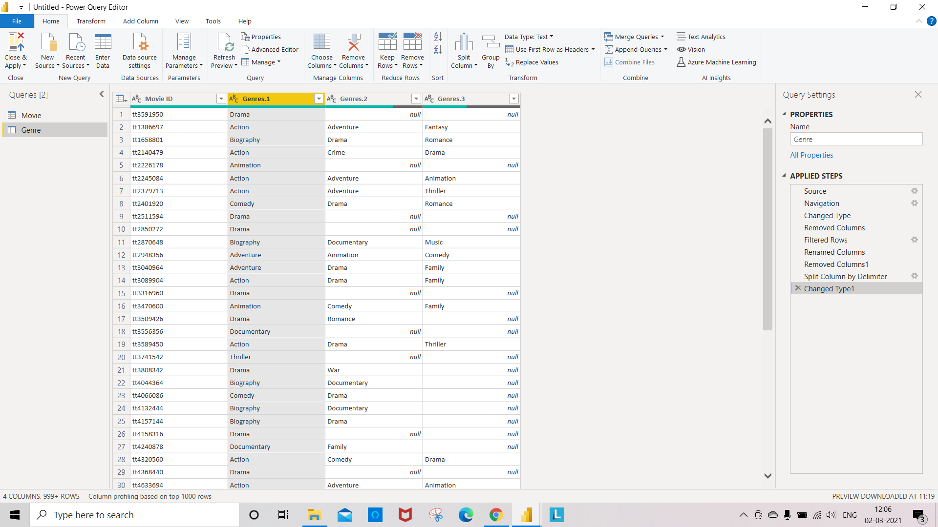

To Unpivot any columns Select the columns , Right click and select Unpivot 🡪 Unpivot Only Selected Columns(You can any select any Option)

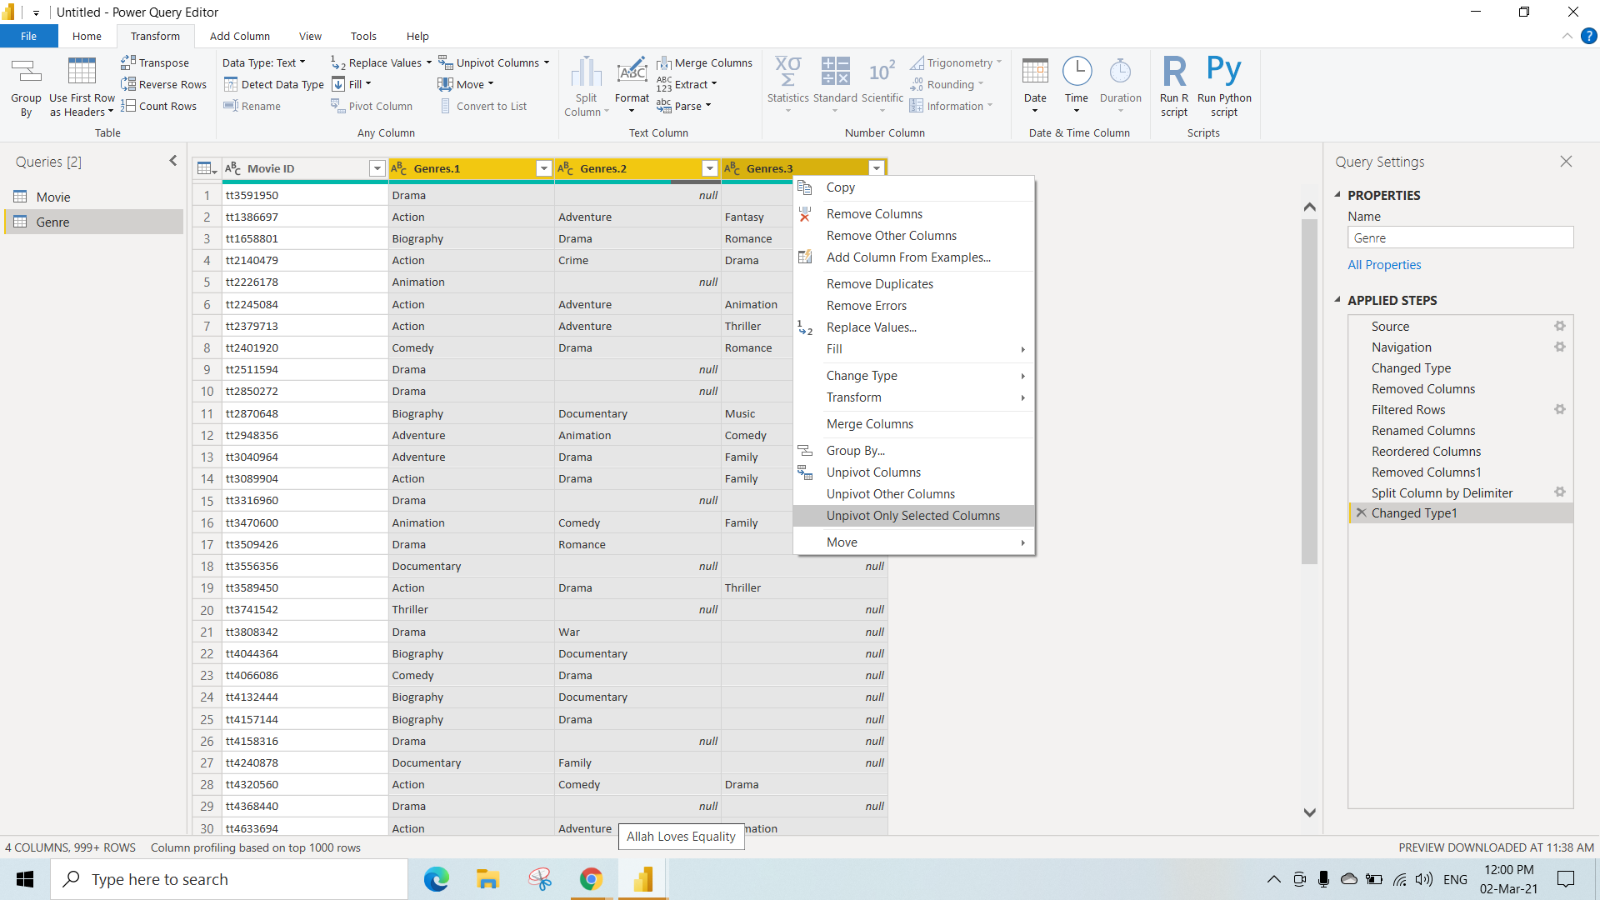

After Unpivot , We get all the genres seperately for particular MovieId and the Genres containing null values will be eliminated

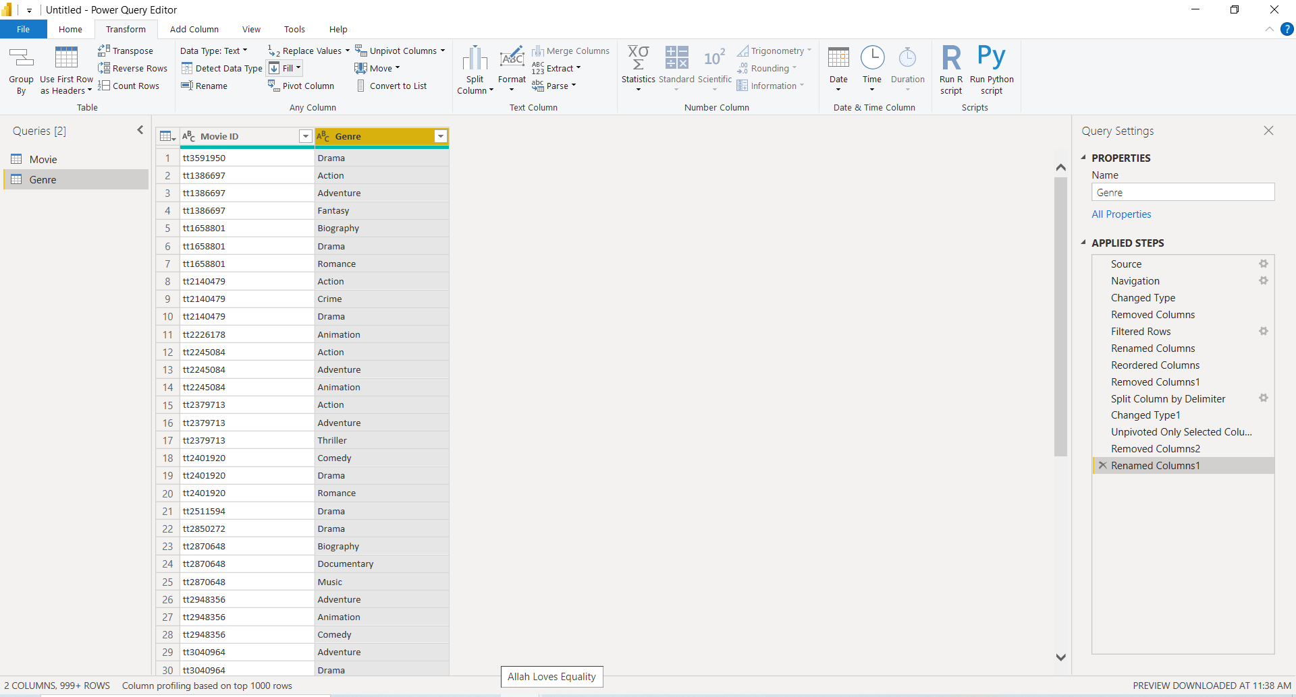

Cleansing Data

We can Replace any values in the field

Here we have Replaced # with Empty Space , click **Ok**

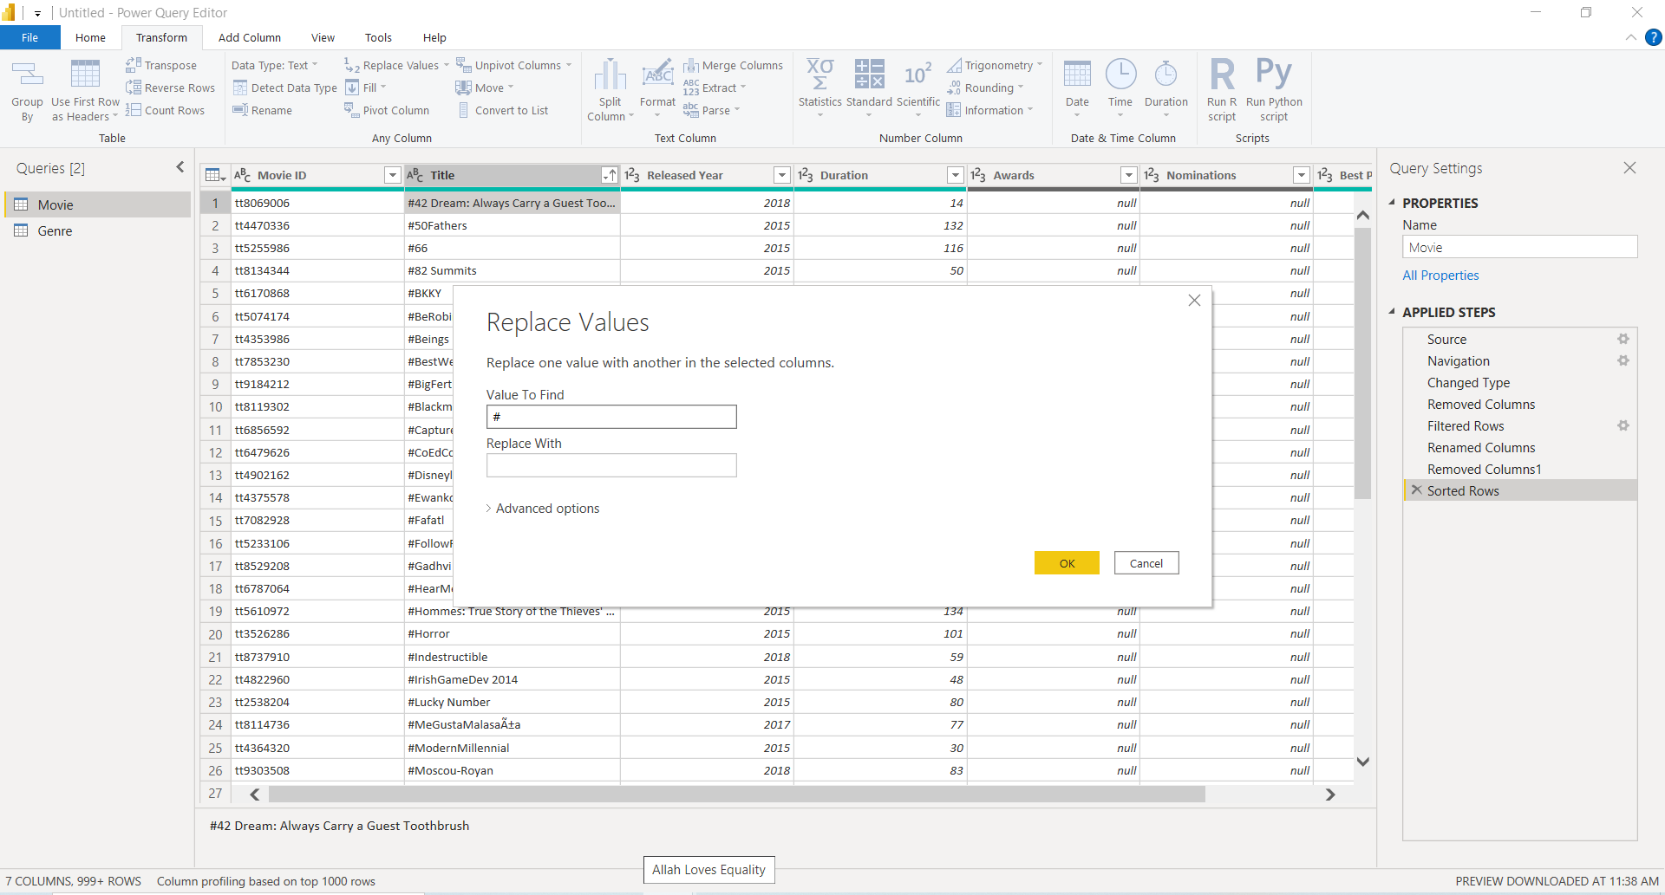

After performing every transformations to apply changes we need to click on **Home 🡪 Close and Apply**

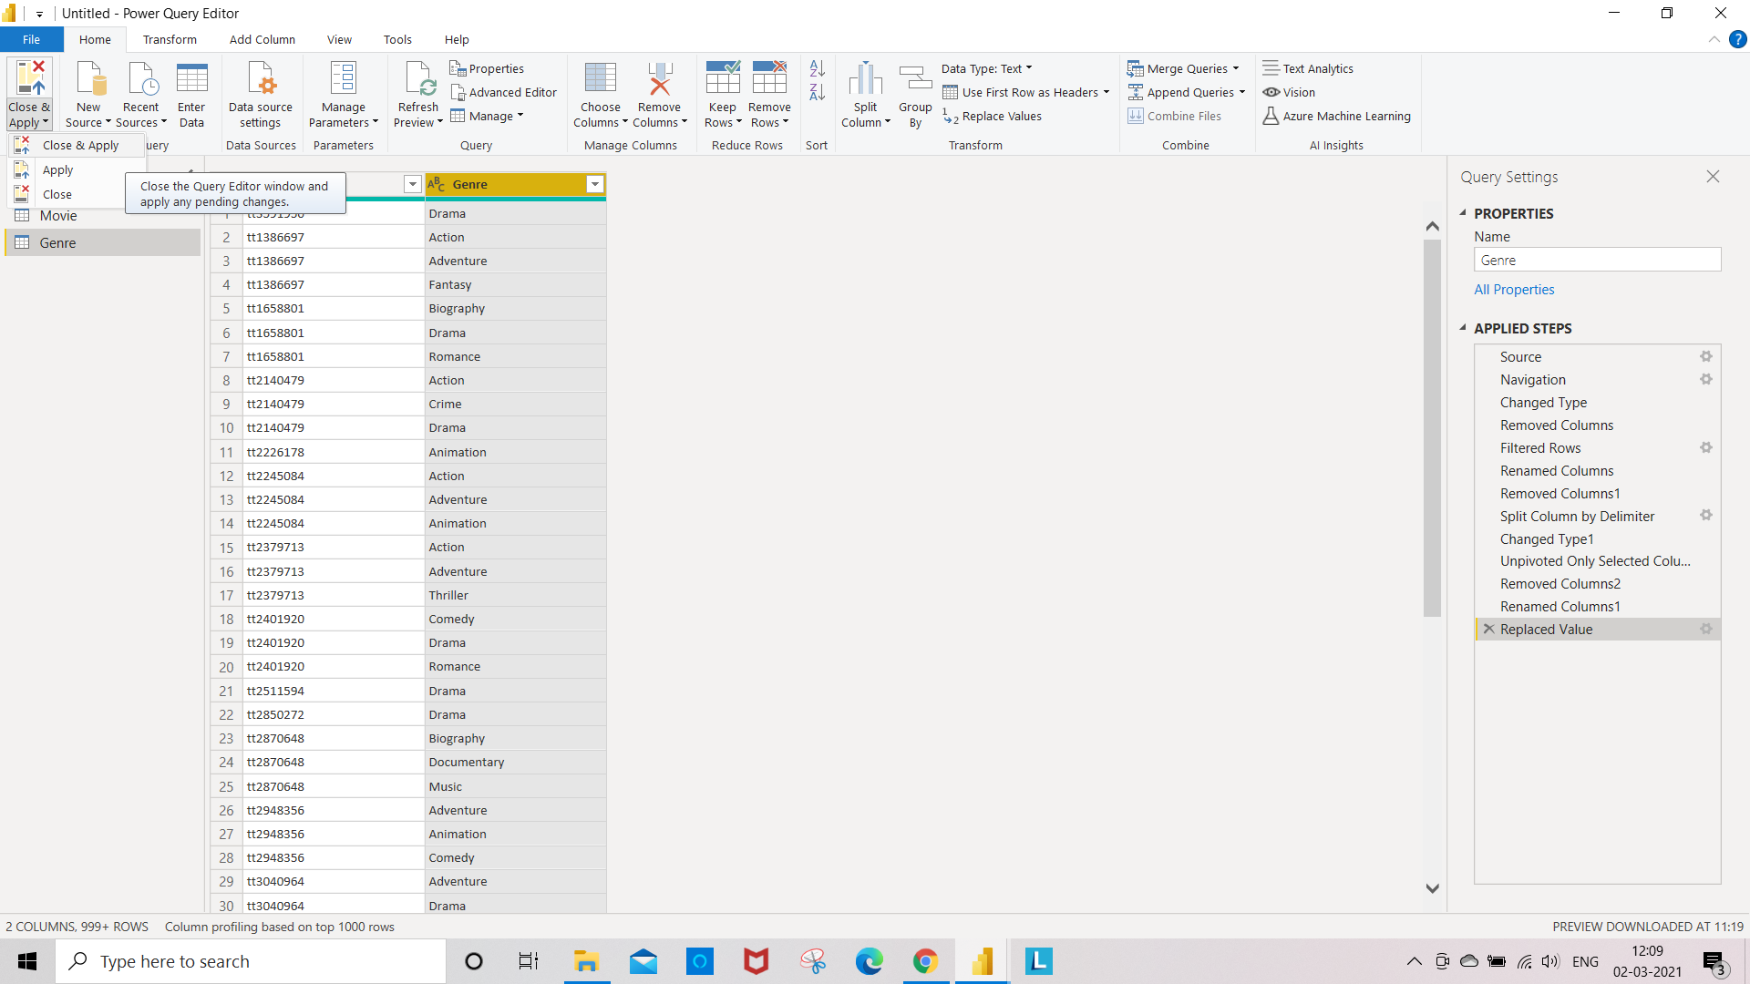

After clicking Close and Apply , It applies all the changes made to the table and closes the Power Query Editor

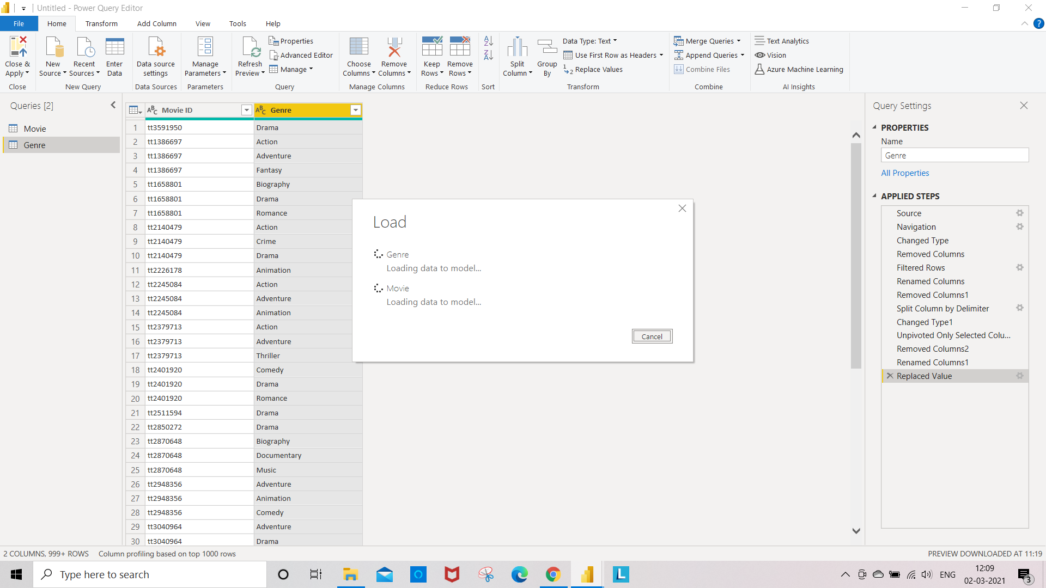

**KO2: Able to Create Data Models in Power BI**

**INTRODUCING THE POWER BI DATA MODEL**

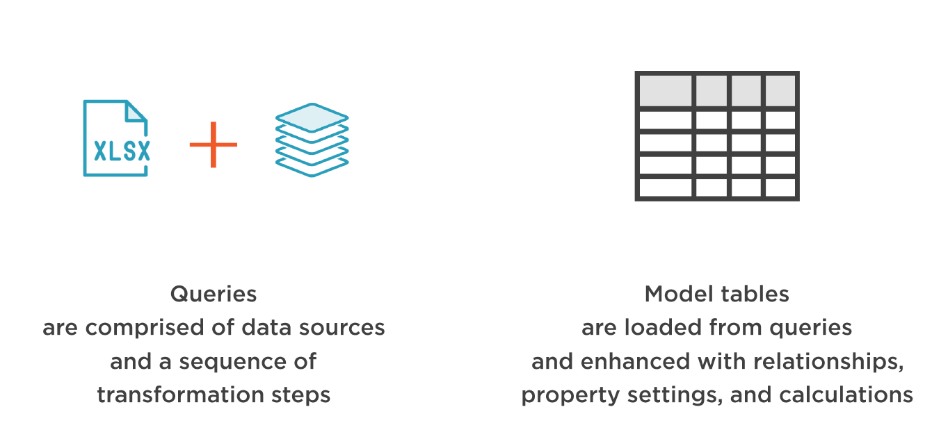

Hiding Columns:

We can Hide Any fields in the table Right click on the field which you want to hide and Click on Hide

Here, we hided the movie id from movies table

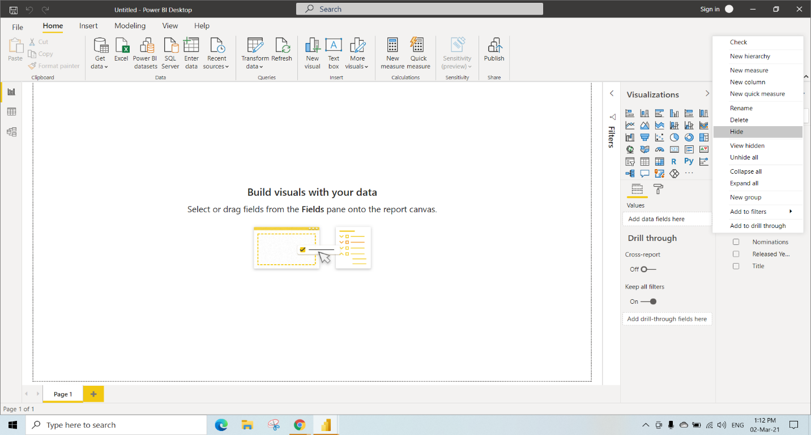

Unhiding the Column by right clicking on the column which is hided

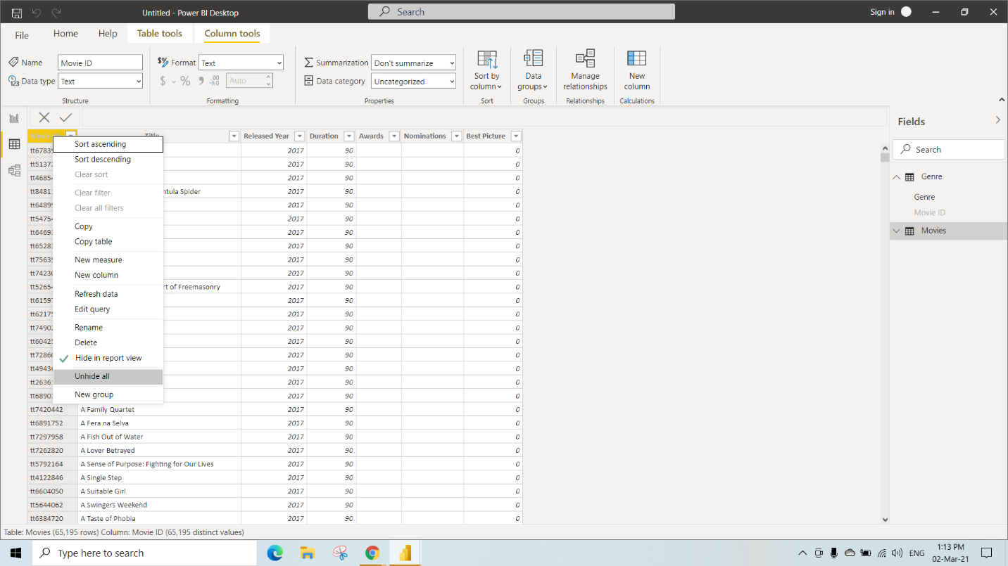

We can add Descriptions to any of the tables loaded

Here we have added description to Movies Table under the properties as

“This table contains data from 2014 and later”

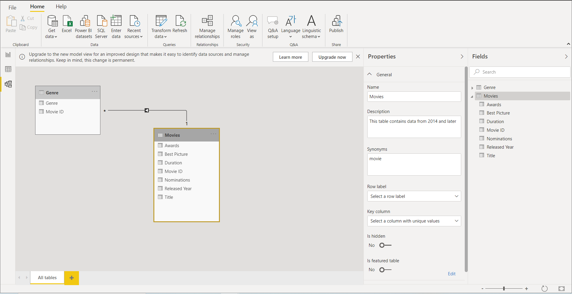

After adding description to movies table When we take the Cursor on the Movies Table We can see the message whatever we have given in the description

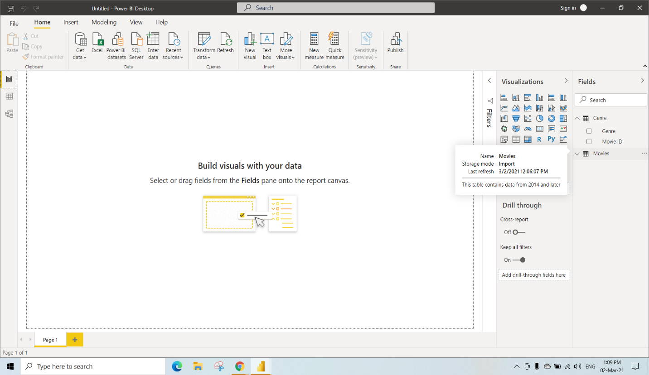

We can also add new Column to the existing table by clicking 3dots on the table and select New Column

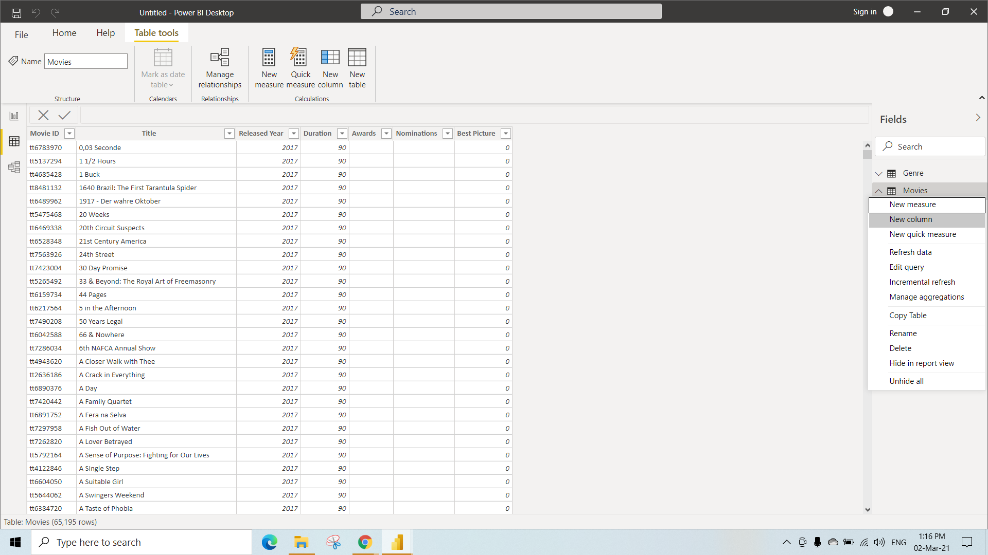

After adding new column with url followed by movie ID , We replaced column_name as movies URL (So it will fetch the given URL <https://www.imdb.com/title/> and movie ID from the selected table)

Movies URL = “<https://www.imdb.com/title/>” & [Movie ID]

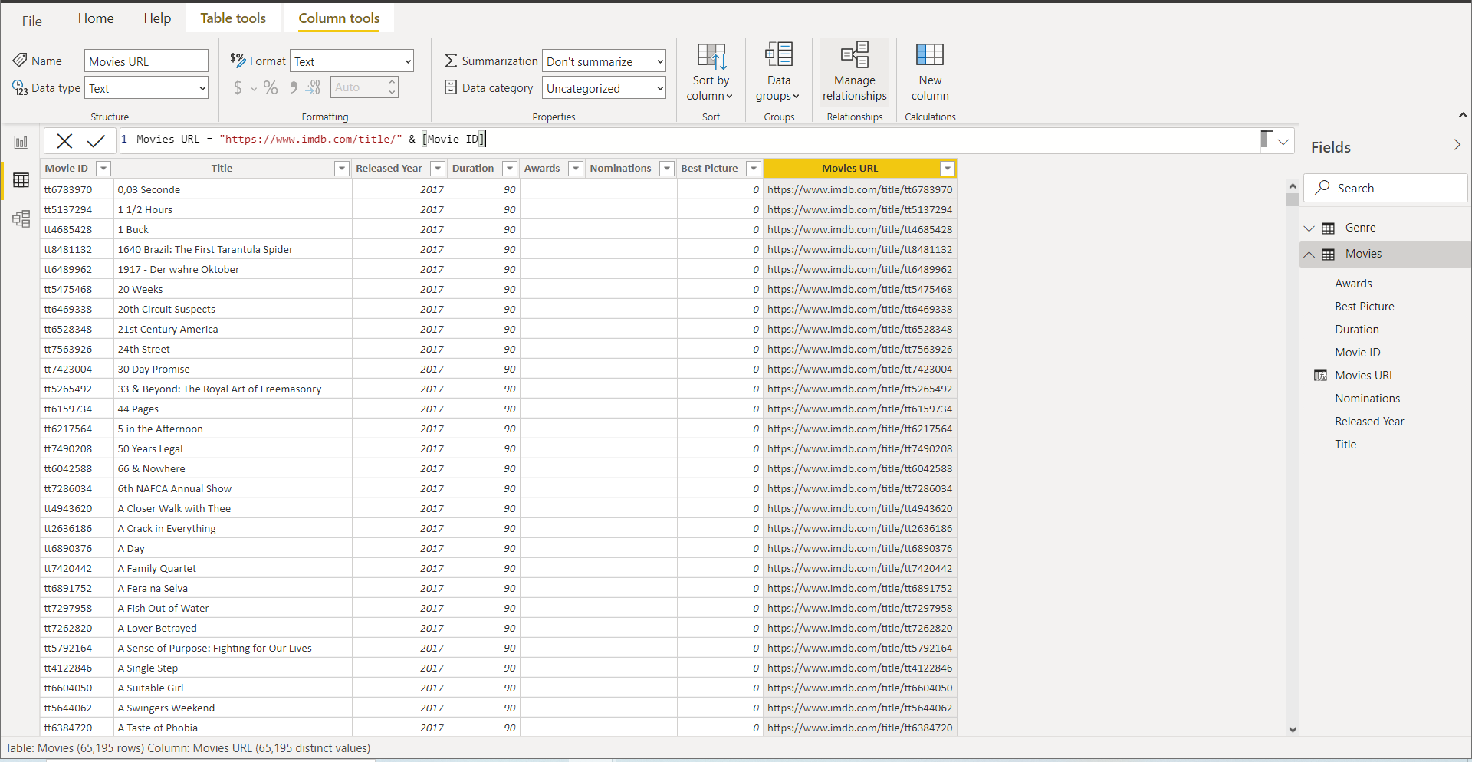

We can add new Measure to the table by clicking 3dots on the table and select New Measure

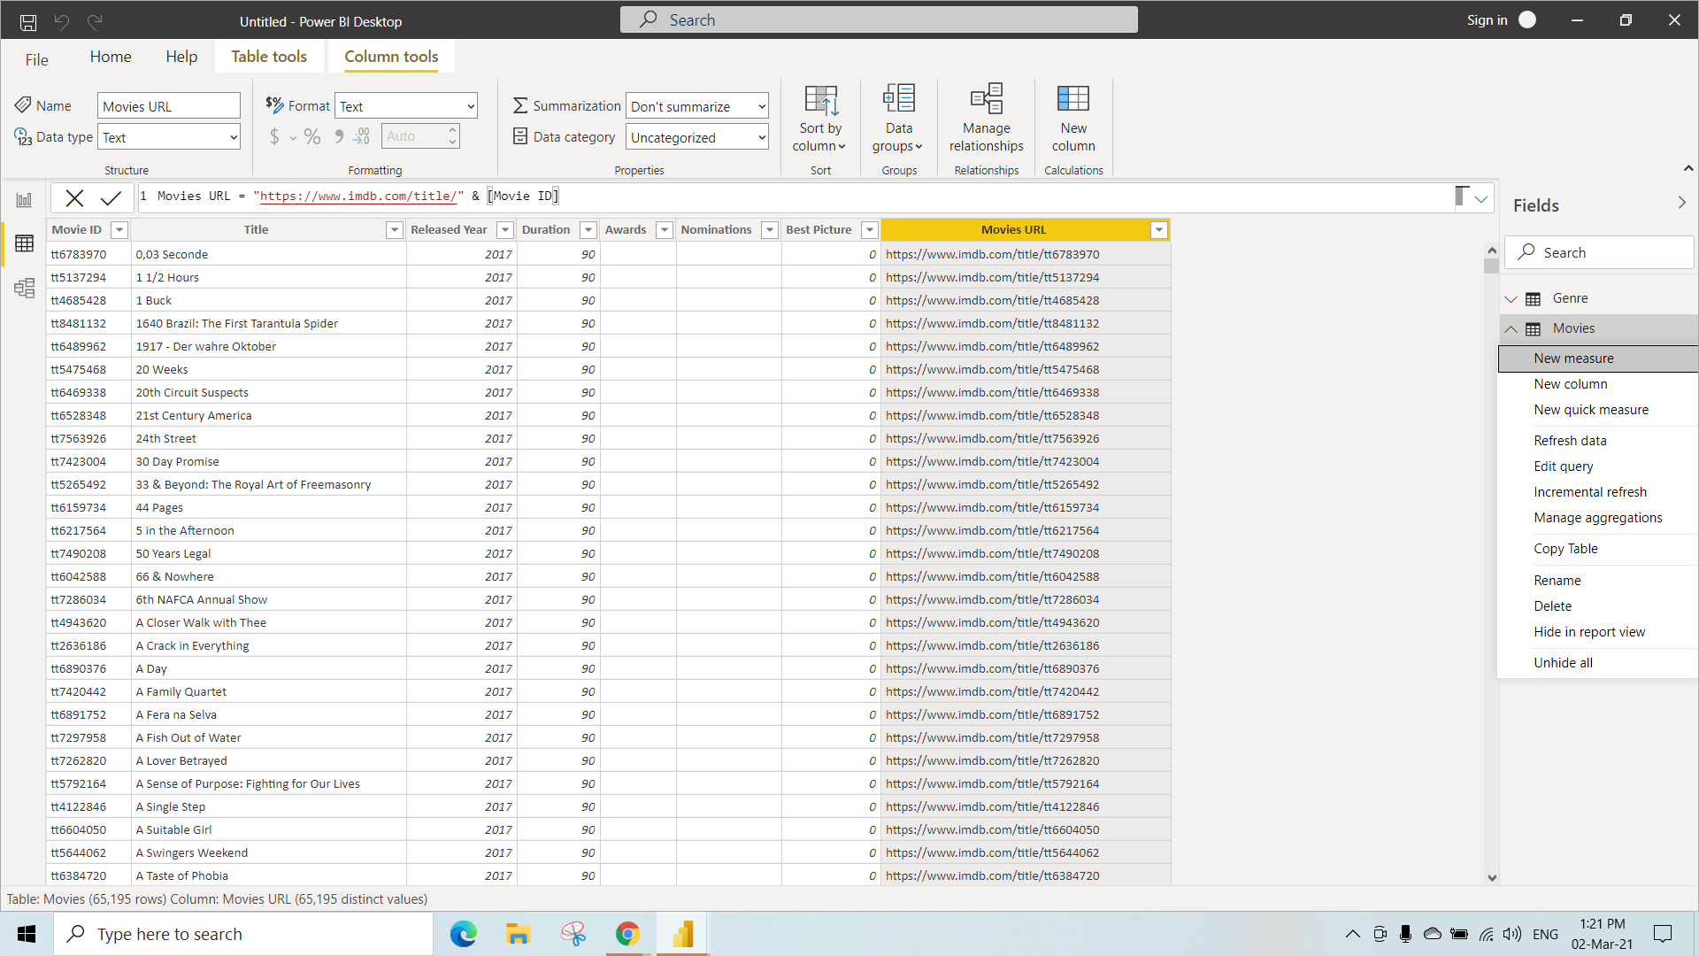

After creating a new measure and renamed it as Movie Count (It will count the number of movies)

Movie Count = COUNTROWS(Movies)

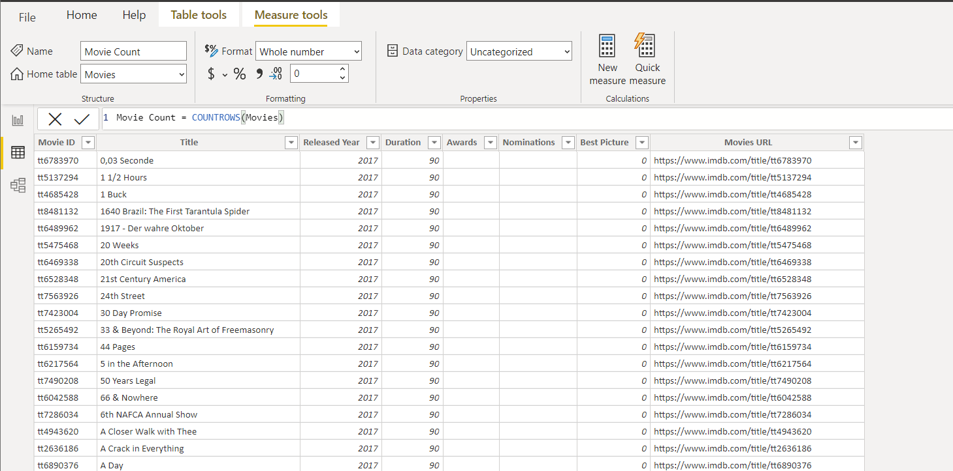

Under the Visualization select stacked Column chart and Select Movie Count and Released Year from the Movies table

This Graph shows Movie count based On Released year

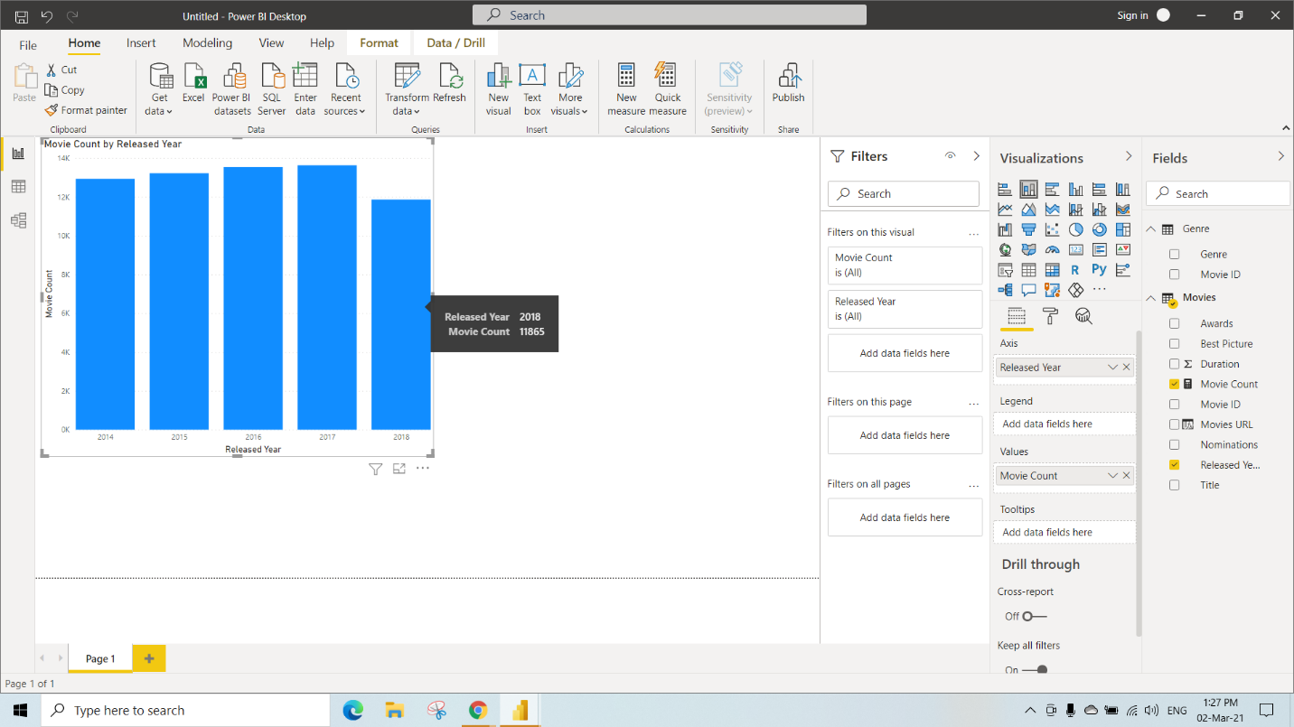

To read values of Movie Count properly, Select , in Table Tools on top and We can See the changes on the graph MovieCount

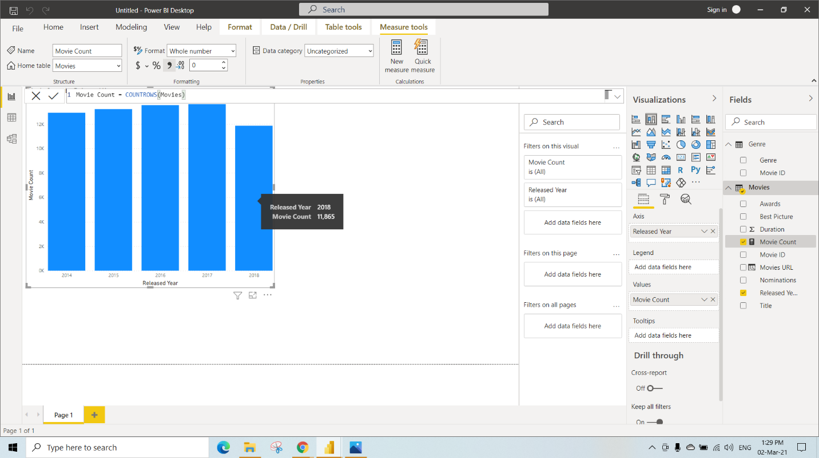

Managing Relationships

Defining Table Relationships

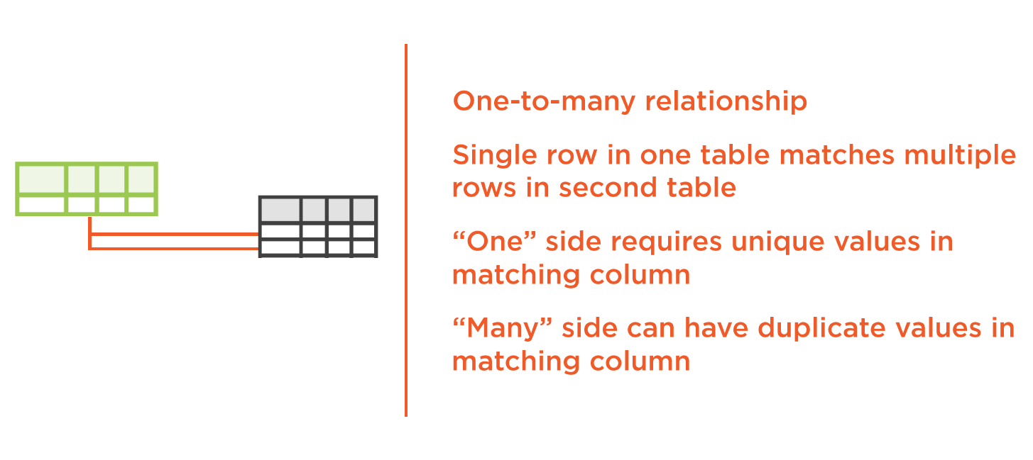

Click on Models Icon Left Side

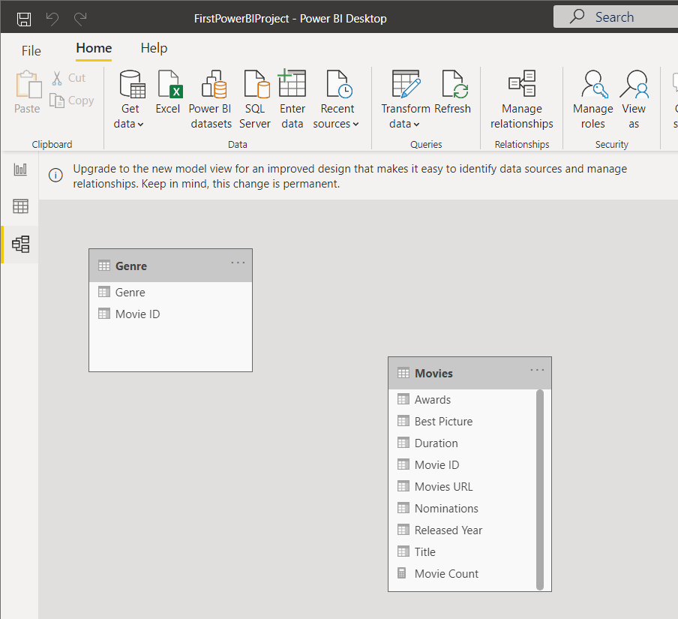

We can connect the Movie Table with Genre By Dragging Movie ID from Movie table to genre(Movie ID) and we can edit the Relationships by double clicking on that link and click **ok**

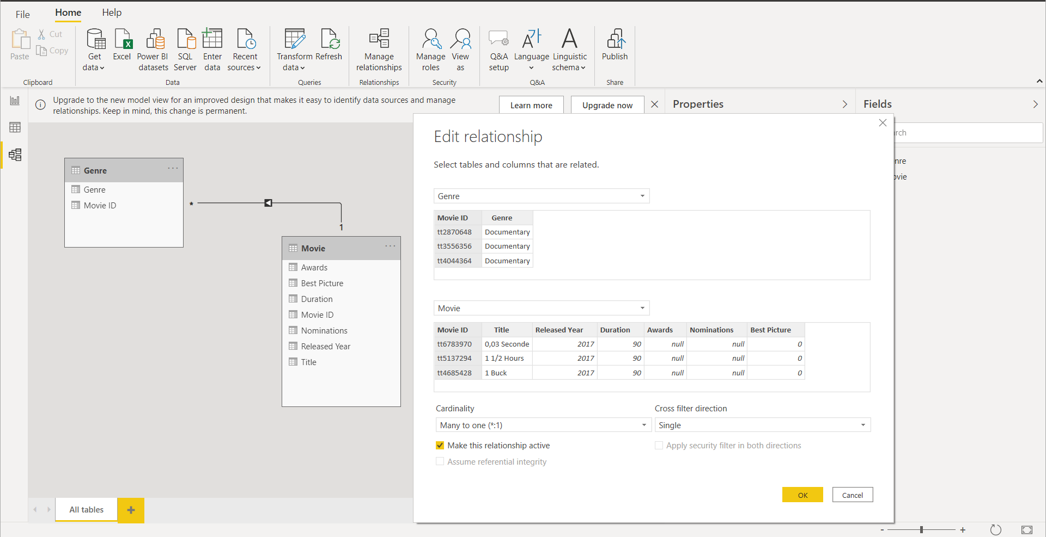

**KO3: Able to Create Reports**

Customization Options:

1. Visualizations:

Axes, Colors, Title, Background, Border, ToolTip and more

1. Static Elements:

Title, Background, Border and more depending on Type

1. Page:

ToolTip, Q&A, Size Background and Wallpaper

Adding Visualization

Under Visualization select table , and Select the Awards, Movies URL and Title from Award Table

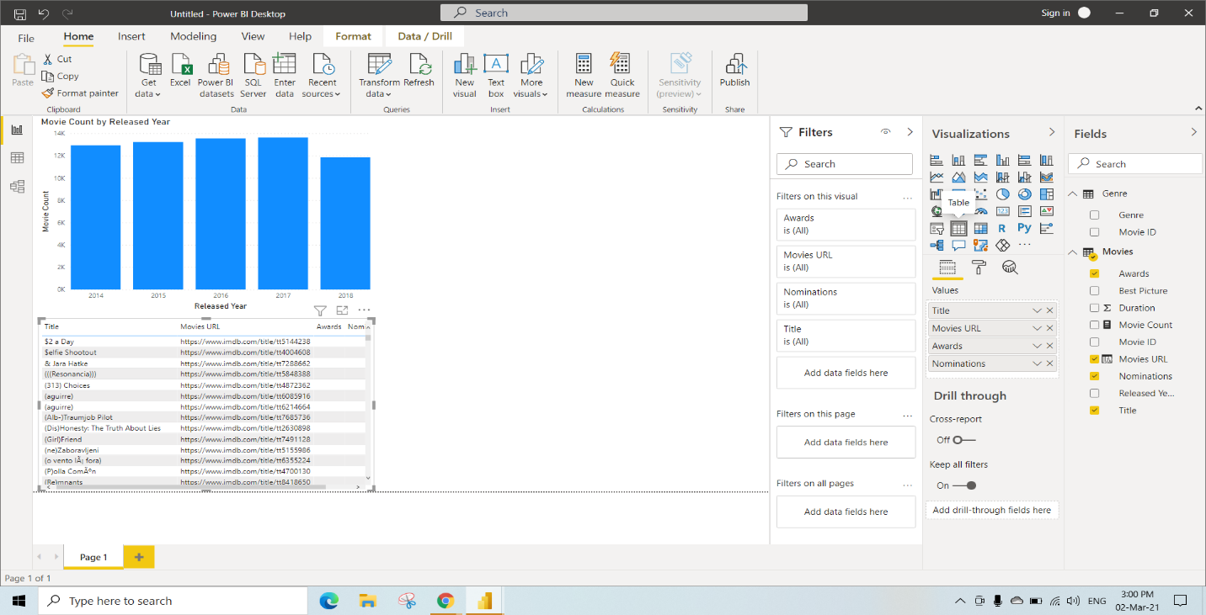

Select Table Visualization and also select Genre from Genre table, Awards from Movies table, make Awards category as Sum by clicking dropdown

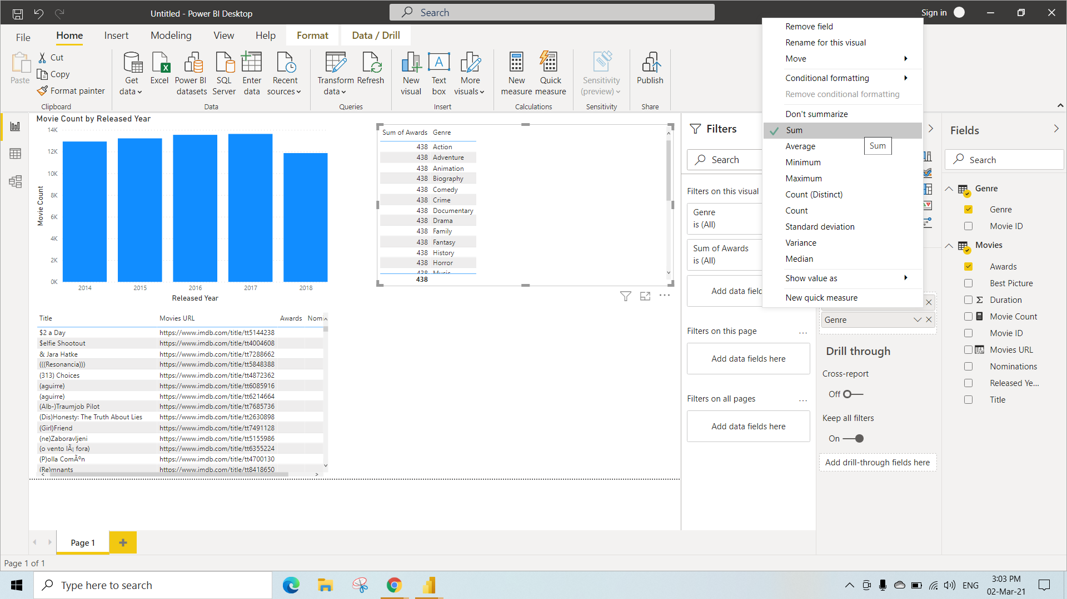

Click the table and select Clustered Column Chart from Visualization

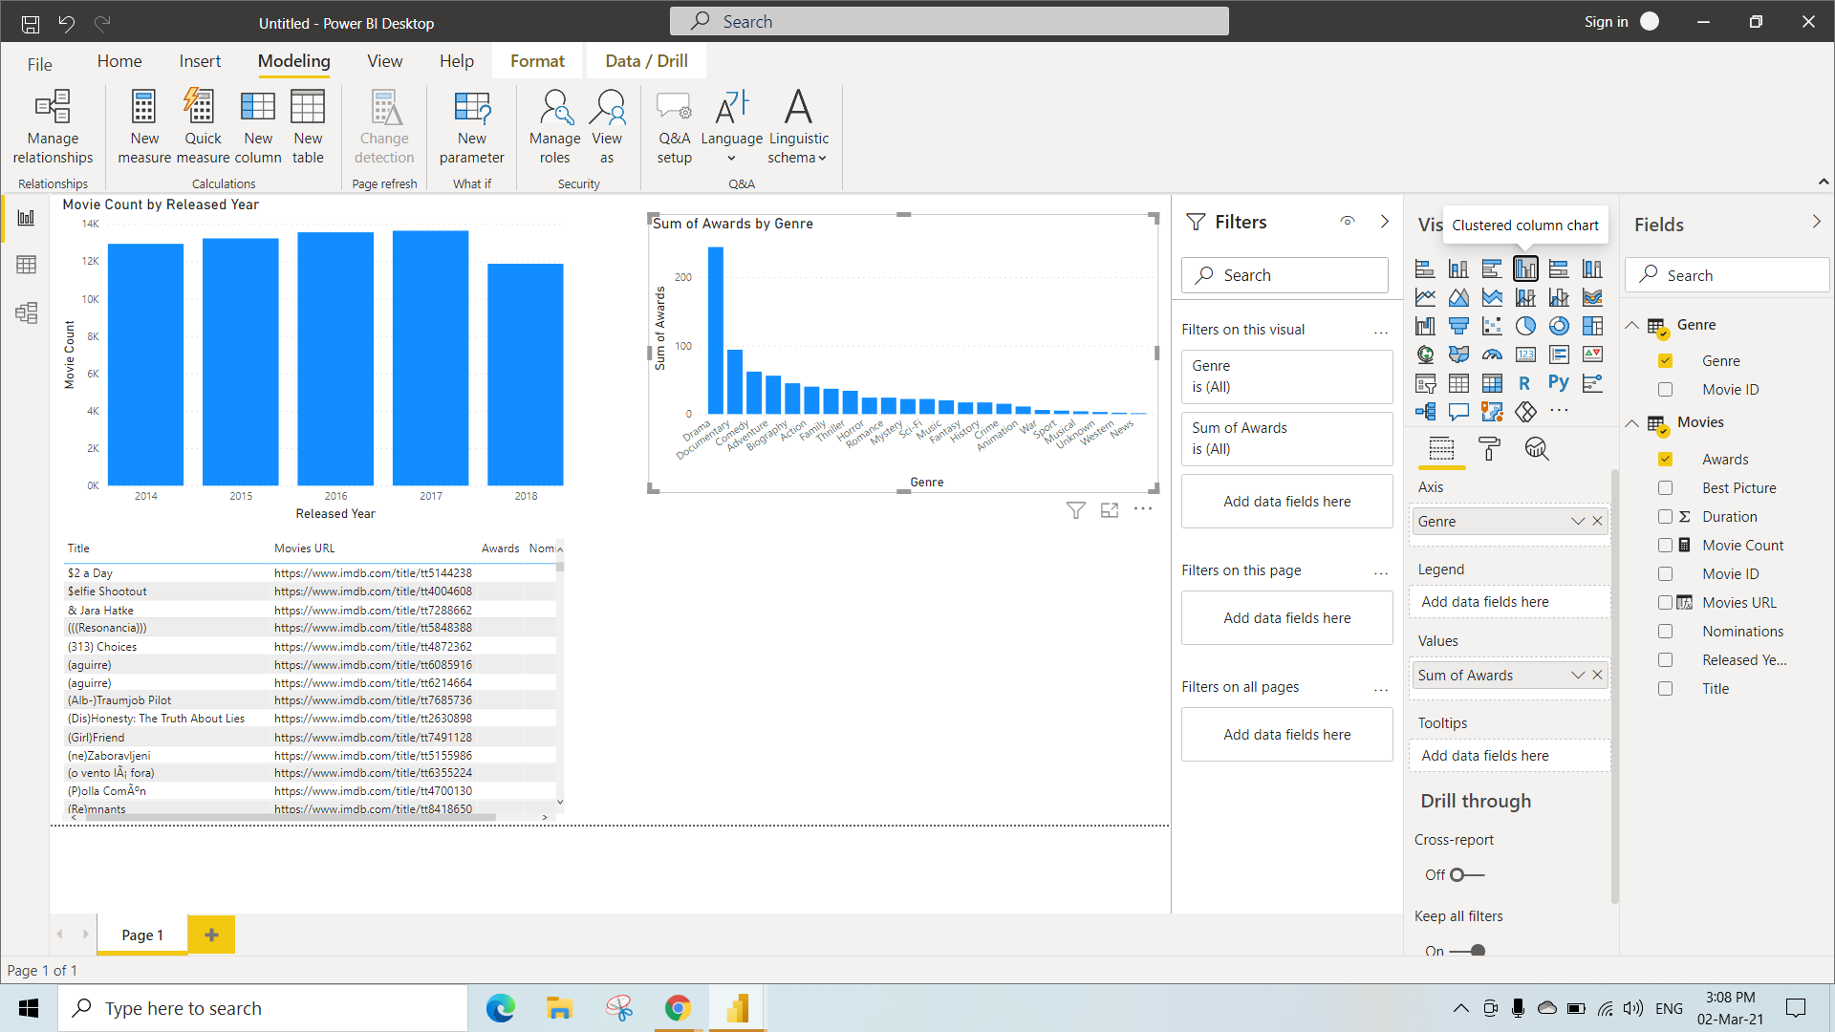

Adding genres column to legend under Visualization field

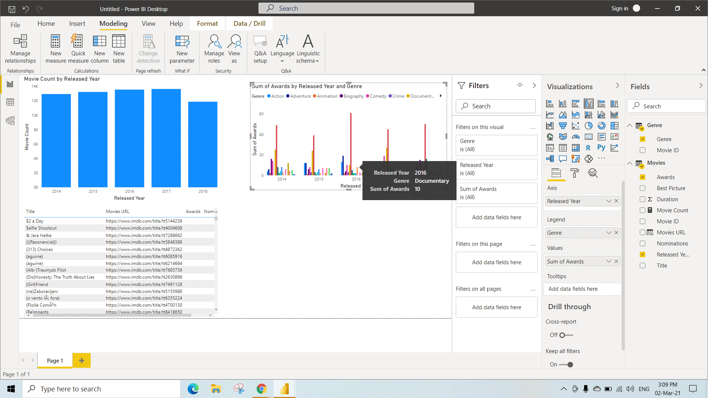

Select Line Chart under Visualization and also Select Duration and Released year columns from Movies Table

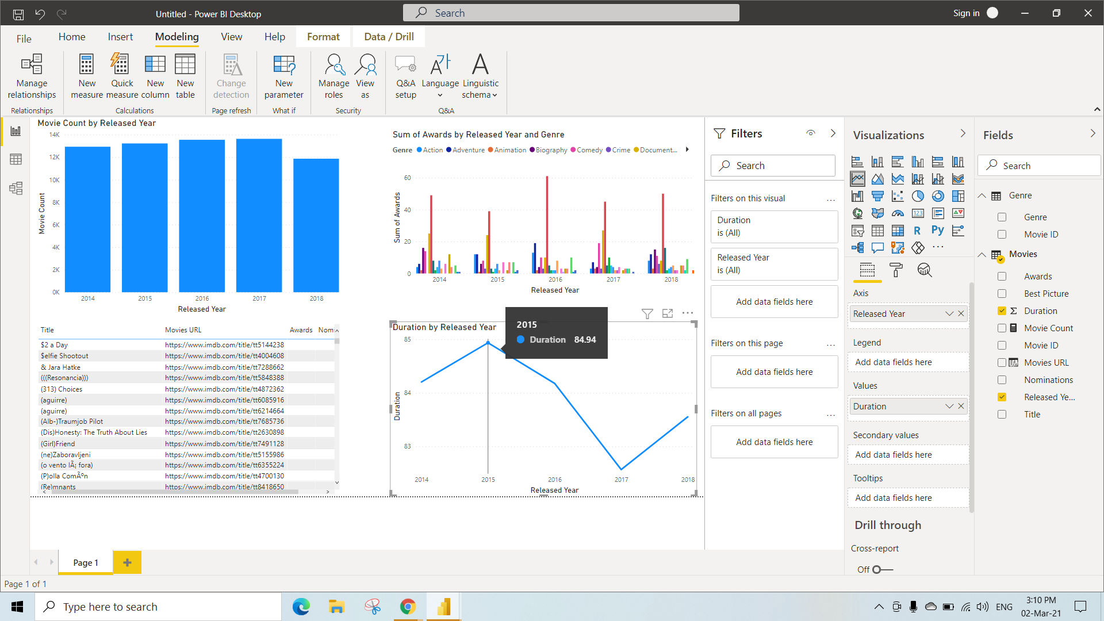

Adding static elements

It includes adding text box, Images, Shapes etc.,

To get static elements

Step 1: Go to insert

Step 2: click on text box (here we have added text as “movies data since 2014”)

Step 3: click on image and select image path (here we have added movie clip art)

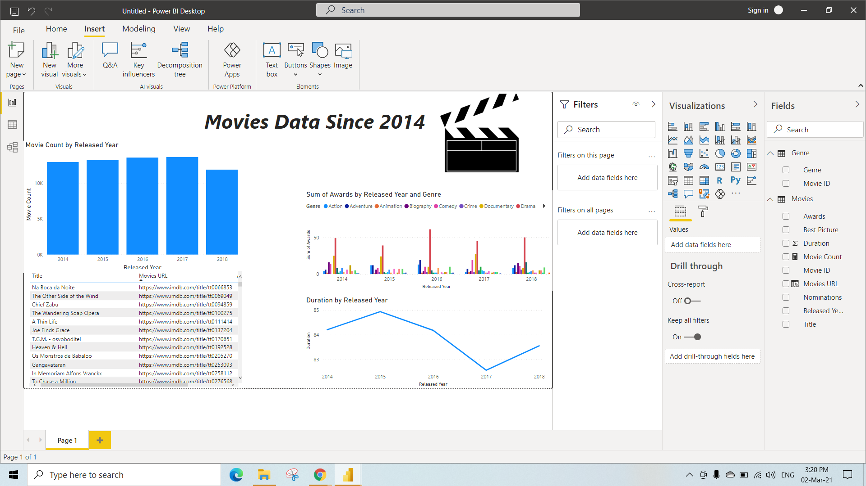

Conditional formatting

To get best picture

Step 1: Click on the table with columns of titles and movie URL

Step 2: Under the visualizations select format (the middle icon)

Step 3: Select conditional formatting

Step 4: On the font color

Step 5: We can select different format by options (here we have selected format by rules)

We can select based on which filed we want to apply condition (here we have selected based on best picture)

We can select summarization with different aggregations (here we have selected minimum)

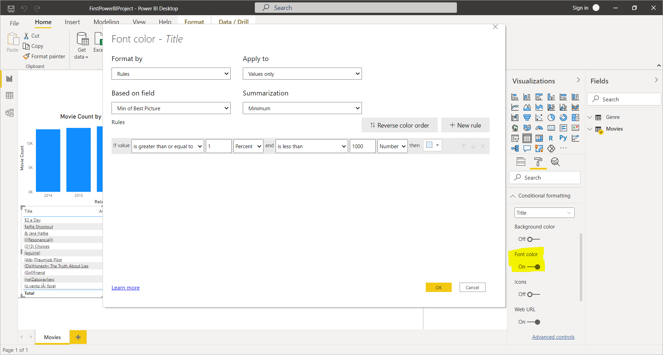

After adding above step we get awards column in the table

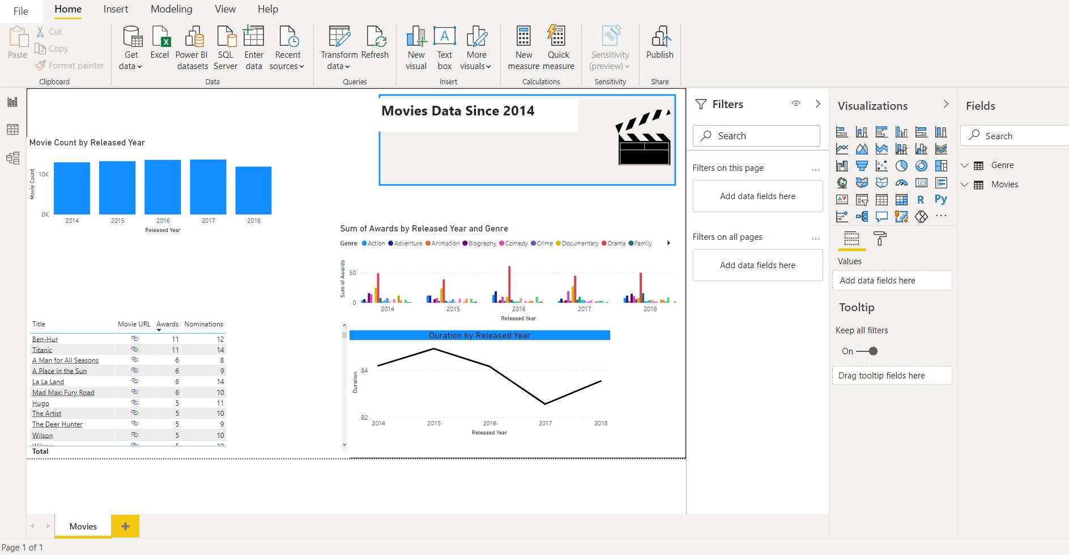

Conditional formatting that is adding movie URL (steps are highlighted)

Step 1: Select table

Step 2: Select format under visualizations

Step 3: Select conditional formatting

Step 4: On the web URL

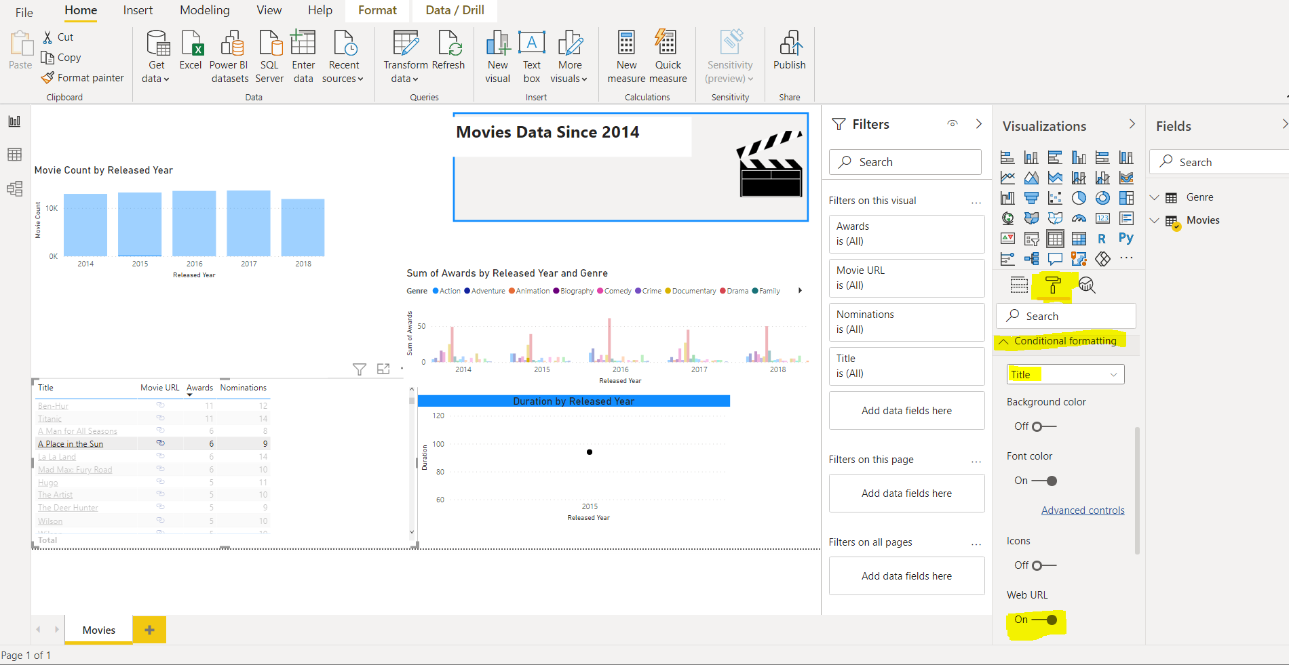

After we on the web URL we need to set conditions

Step 1: Select format by option

Step 2: Select the column based on which to apply condition, click **ok**

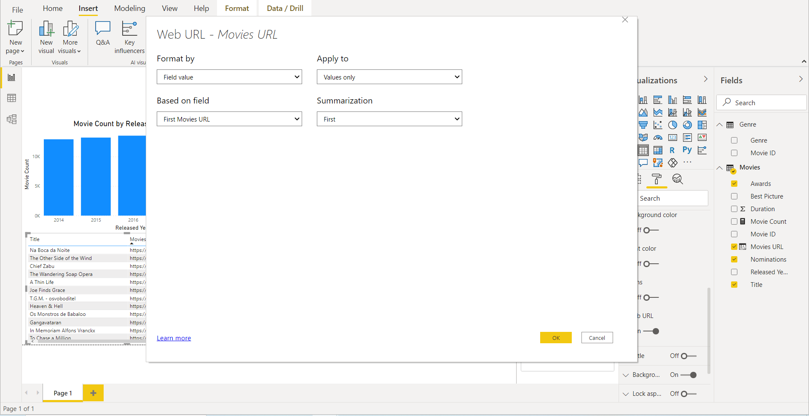

After adding movie URL every movie in movie URL field is in the form of URL



Report Publication

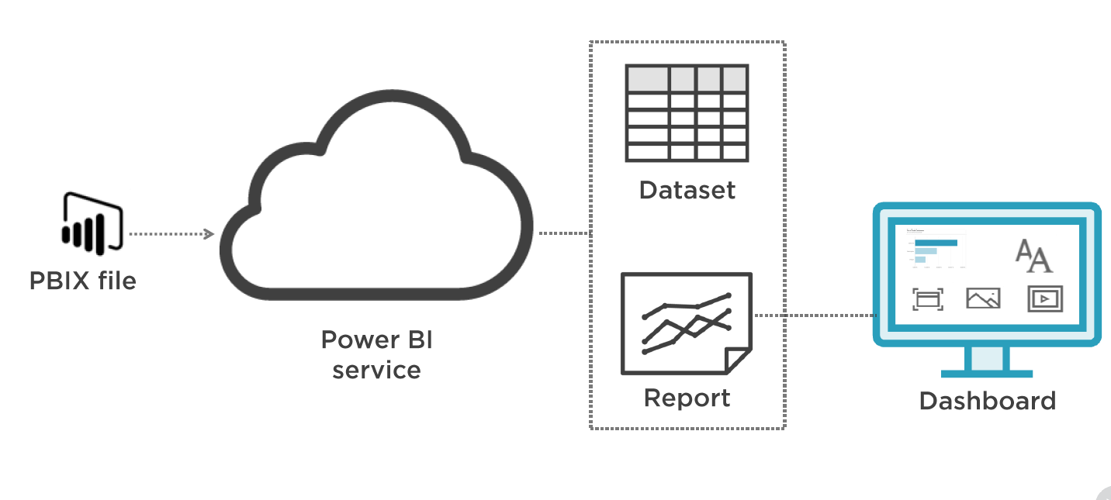

Publishing report and creating dashboard

To publish we must click on **publish** in the **home**

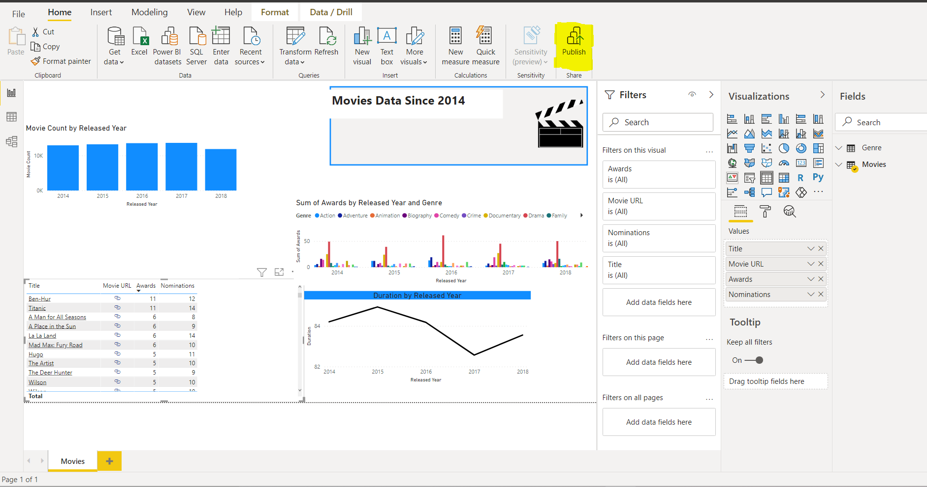

After clicking publish, If you're using Power BI Desktop for the first time you're prompted to fill out a form or sign in to the Power BI service before you continue to Publish. So you need to sign in using your credentials

From there, you can begin creating data models or reports, then share them with others on the Power BI service.

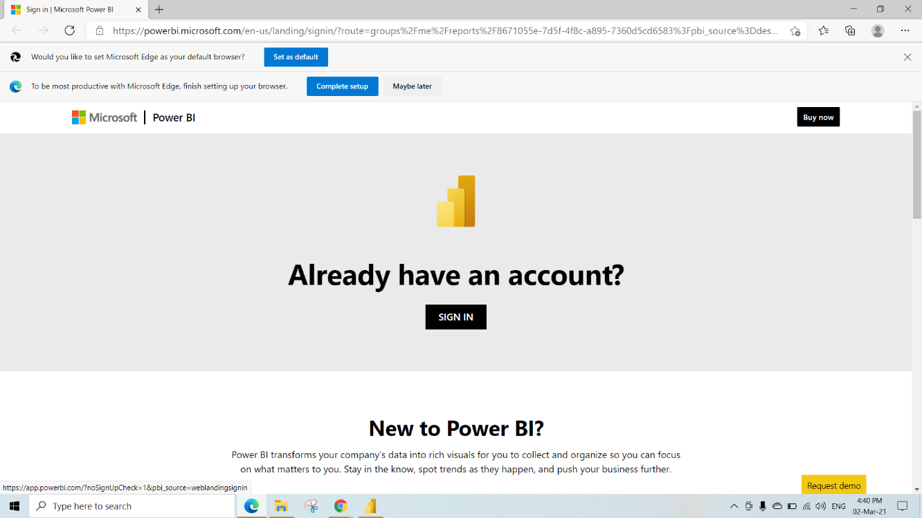

After signing in we need to select the workspace to publish our report to powerBI service

Select **My workspace** and click on **select**

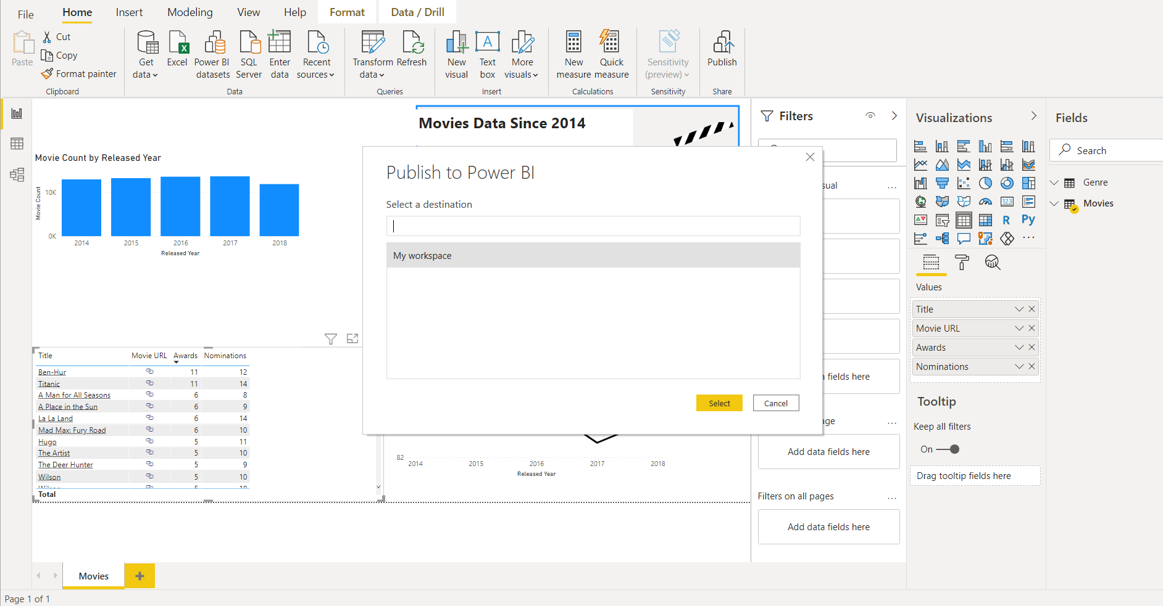

While Publishing to powerBI we will get this

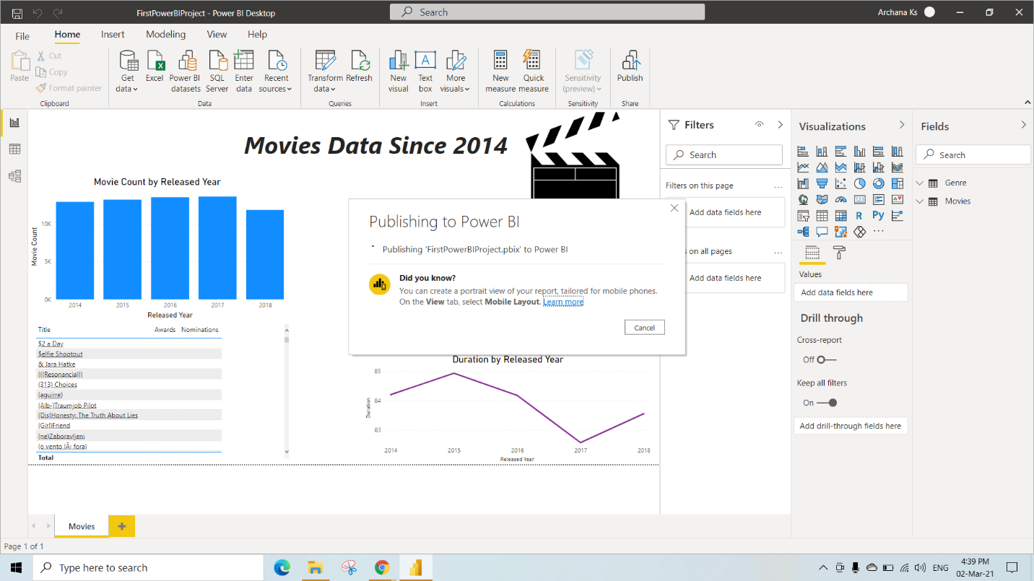

After Publishing is Successful, Click on “open ‘movies-report-begin-pbix’” to open the published report

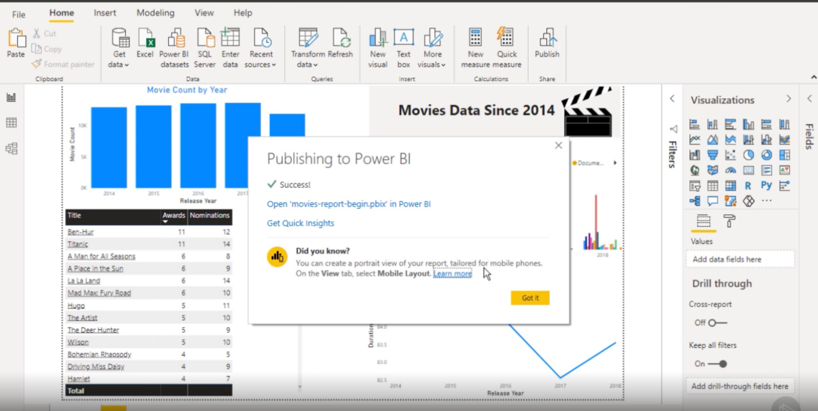

After opening the published report we can check report under My workspace as we selected My workspace while publishing

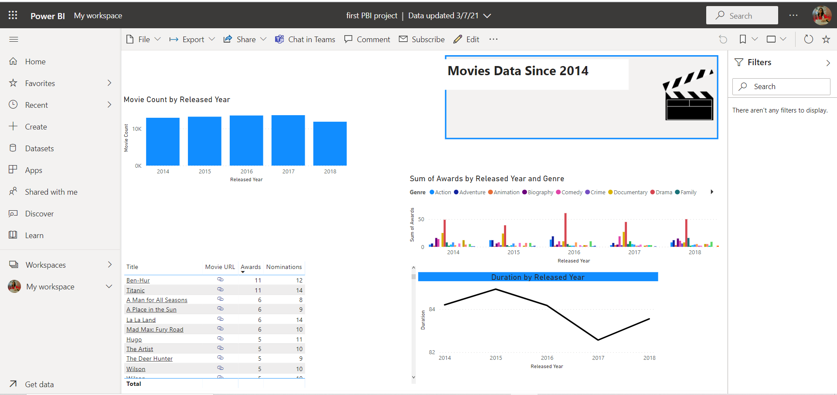

Click the dropdown of **My workspace** under reports we can see our published report “FirstpowerBIProject”.

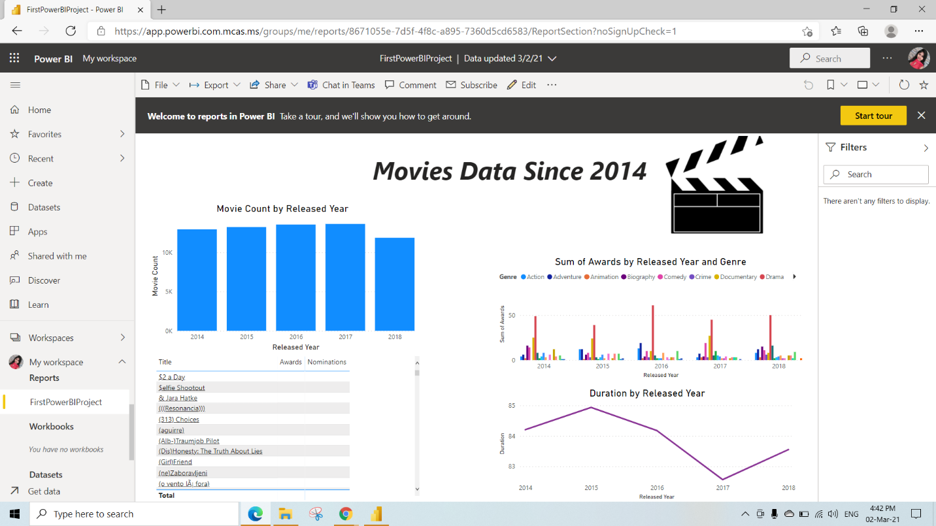

We have dataset created once we publish our report

We can see it under **My workspace** , under **dataset** dropdown

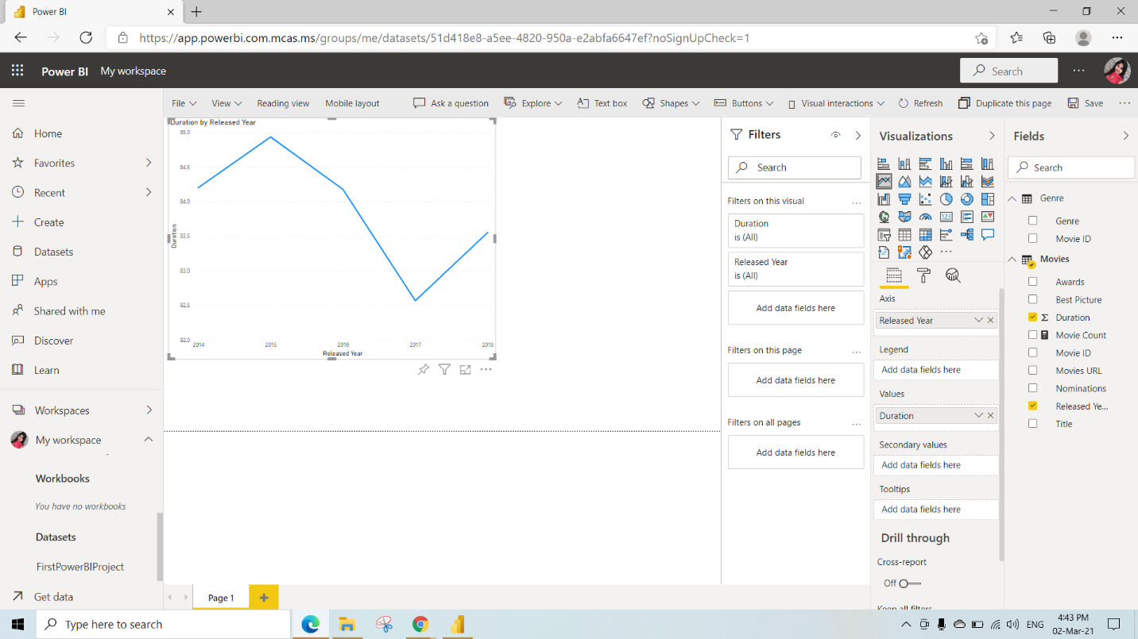

To create dashboard

Step 1: click on the report (FirstpowerBIProject)

Step 2: click on **pin visual** icon

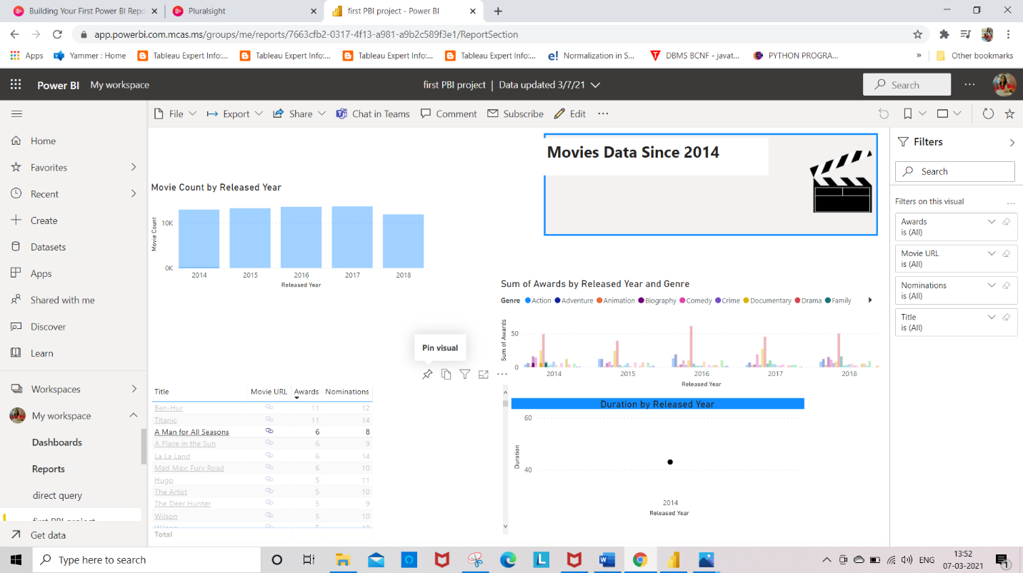

After clicking on pin to visual icon we get this where we need to give dashboard name(here we are giving “Moviedashboard” as dashboard name)

Click on **pin**

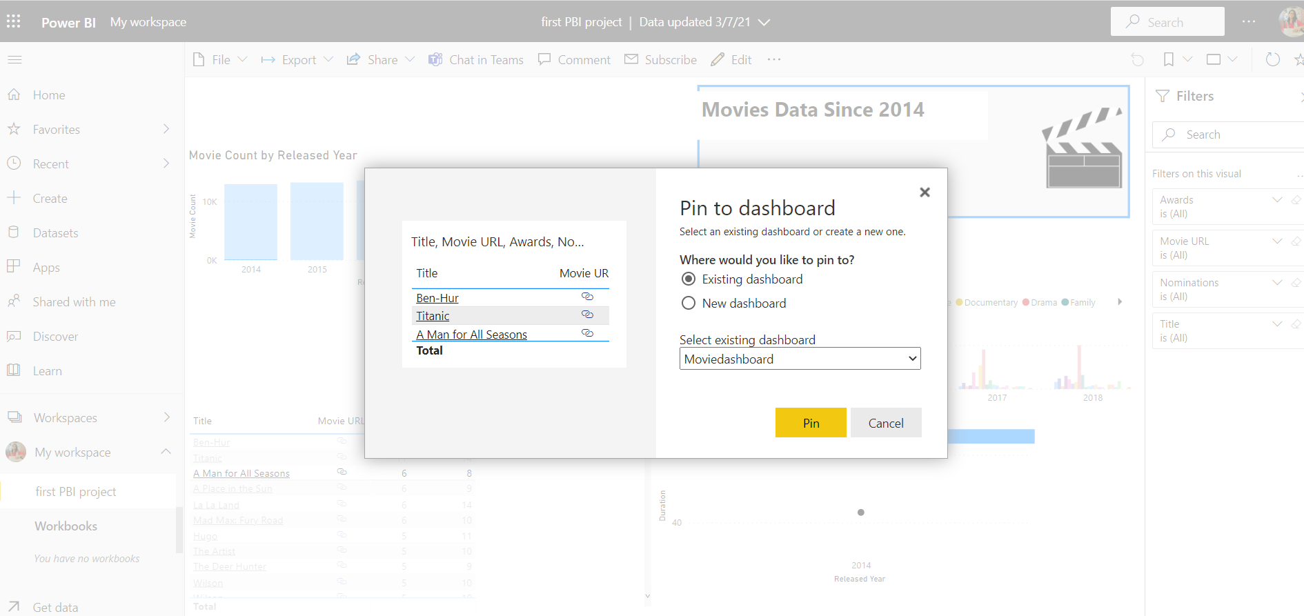

Now the dashboard is created (from the Pop-up we can select Go to Dashboard)OR

Step 1: Under the **My workspace** click on dropdown

Step 2: Click on **dashboard**

Step 3: We can see the dashboard name we have created

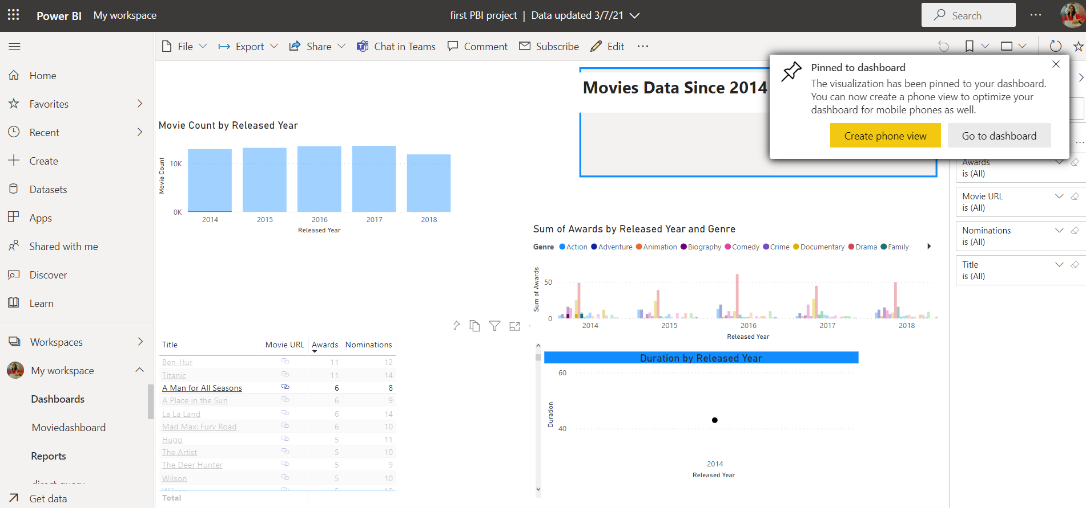

Creating Mobile Layout:

To create mobile view of the report

Step 1: Go to **view**

Step 2: Click **Mobile layout**

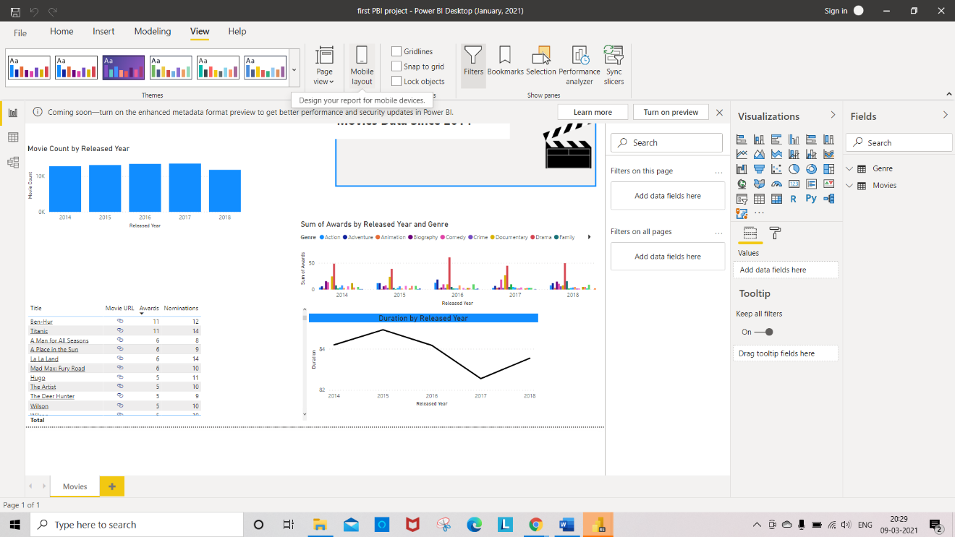

Drag and drop the visuals to the mobile layout which you require in your mobile layout

